

**Paradise**

**Chaser**

Online Travel & Tours Agency

University of

Technology Mauritius

*School of Innovative Technologies*

*and Engineering Department of*

*Business Informatics and Software Engineering (SITE)*

Module Name : System Development Project

Module Code : PROJ3105C

Programme : BSc (Hons) Web Technologies

Supervisor Name : Mr. A.Tulsi

Student Names & ID : AUCKBARAULLEE Fardin (160285)

Student Cohort : BWT16AFT

Submission Date : 31.10.2018

This dissertation is submitted in partial fulfilment of the requirements for the degree of Bachelor of Science with Honors in Web Technologies

**Abstract**

Online Tours and Travels Project is web-based application specially designed for travel agents to book tickets through online and provide travels information.

Even with the growth of online travel booking sites, the travel agency industry is expected to grow over the next several years. Online booking has forced traditional travel agencies to market themselves in new ways, often by catering to niche markets.

Today, travelers who want a well-planned vacation but don’t want to do the planning can find a travel agent who caters to exactly what they’re looking for. Agencies often handle transfers between multiple destinations, event planning services, group travel arrangements and more. Working with a travel agent can help take the stress out of travel.

The purpose of this website is that it can give any kind of travel packages to the general public. Any customer can register onto the application.

The benefits and advantage of online travel agencies is having low cost and convenience. Online travel agencies are also available at any time, as long as you go online, you have all the time for bookings that you need to complete. With all these online agencies, you have all the option to choose the best deal and the right budget for you. It also gives the comfort in the country of destination; you are provided with the transfer to your hotel and agencies are the one taking care of any problems you might encounter.

Article Source: <http://EzineArticles.com/4138156> https://www.consumeraffairs.com/travel/agencies.html

**Acknowledgement**

I would like to express my deepest appreciation to all those who provided me the possibility to complete this report.  A special gratitude I give to my final year project supervisor, Mr. A. Tulsi whose contribution in stimulating suggestions and encouragement.

And finally, I would like to thank my close friends and family for their support. You all have helped me to focus on what has been hugely rewarding and enriching process.

Table of Contents

1.0 Description of current system 8

1.1 Existing Problems 8

1.2 Proposed Solution 10

1.3 Goals and objectives 11

1.4 Other goals and objectives 11

2.0 Feasibility Study 13

2.1 Technical Feasibility 13

2.1.2 The 3-Tier Architecture 13

2.1.3 Comparing different possibilities 14

2.1.4 Conclusion 15

2.1.5 Hardware requirements 17

2.1.6 Software requirements 17

2.2 Operational Feasibility 18

2.3 Economic Feasibility 21

2.3.1 Cost-Benefit Analysis 21

2.3.2 Payback Period 22

2.3.2.1 Tangible Benefits 22

2.3.2.2 Intangible Benefits 22

2.3.3 Sensitivity analysis 23

2.3.4 Conclusion: 24

3.0 Chosen Methodology 26

3.1 Agile methodology 26

3.2 Agile software development principles 26

3.3 Advantages of Agile model: 27

3.4 Disadvantages of Agile model: 28

4.0 Project Planning 30

4.1 Gantt Chart 30

4.2 Work Breakdown Structure (WBS) 31

4.3 Project Charter 32

4.4 Project Scope 33

4.4.1 Importance of the project 34

5.0 Requirement Analysis 36

5.1 Functional Requirement 36

5.2 Non-Functional Requirement 36

6.0 Design 39

6.1 Database design 39

6.1.1 ERD 39

6.1.2 Class Diagram 40

6.1.3 Use case diagram 41

6.1.3.1 Use Case Specification 42

6.1.4 Data Dictionary 44

6.2 User Interface Design 49

Customer Section 49

Admin Section 53

7.0 Implementation 56

8.0 Testing 61

8.1 Whitebox testing 61

8.2 Black Box testing 69

10.0 Conclusion 72

10.1 Overview of the system 72

10.2 Strength of the website 73

10.3 Weakness 73

10.4 Future improvements 73

11.0 References 75

12.0 Appendices 77

12.1 User manual 77

12.2 Annex 93

Figure 1: 3-Tier Architecture 13

Figure 2: Payback Period 23

Figure 3: Sensitivity Analysis Scenario 1 23

Figure 4: Sensitivity Analysis Scenario 2 24

Figure 5: Gantt chart part (1) 30

Figure 6: Gantt chart part(2) 30

Figure 7: Work Break down Structure 31

Figure 8: ERD - Physical 39

Figure 9: Class Diagram 40

Figure 10: Use Case Diagram 41

Figure 11: Homepage interface design 49

Figure 12: Register interface design 50

Figure 13: Login interface design 50

Figure 14: Book Accomodation interface design 51

Figure 15: Flight interface design 51

Figure 16: Car rental interface design 52

Figure 17: Manage Flight, Accommodations, Car interface design 53

Figure 18: CRUD - Create New interface design 54

Chapter 1: Description of current System

# 1.0 Description of current system

The existing system is a completely manual one. Information is sent to correspondents via fax and there is no guarantee that it has successfully reached its destination. Staffs communicate with each other by telephone or walking to the people they want to talk to. Advertising is done by newspapers or papers glued to their window panes so as to allow people to know about different promotions or packages or new arrivals.

Customers have to walk in the agency to know more about an item which sometime causes some customers to walk away because of too much customer inside and they have to wait too much time.

Data about customers and other records such as bookings and other are stored in files which are sometimes vulnerable to data theft, data destroyed by natural calamities.

## 1.1 Existing Problems

* Slow system

Since the existing system is a manual system, it is very difficult to maintain historical data. It is difficult to maintain important information in books. More manual hours are needed to generate required outputs. It is tedious to manage historical data which needs so much space to keep all previous ledgers book and so on.

* Time consuming

Transactions made within the company are mostly on paper and there are procedures to go by when reserving or buying a certain package or specific items. Hence these factors make the system slower which may discourage clients from coming back to the agency. Currently customer in order to reserve or order a package can call or walk in the agency showroom then the staff will go and check if whatever asked by the client is available. Thus, there is a huge amount of paperwork involved during any process.

* Lack of security of data

Since documents are bulky and may fall in the hands of untrusted people, it can be harmful to the company if these documents are leaked in today’s competitive world. Lack of security of data grants access to anyone and may lead to data misuse. Therefore, records are prone to getting lost or misplaced.

• Communication process

This company makes use of a fax machine or transmission, although it is secured against remote attacks but we do not know if the document has reached its destination successfully. Phone calls are made in order for a customer to get certain information about the available packages and other services.

• Scheduling

When a customer wants an appointment with the company in order to visit the showroom, it is recorded in a book. The staff go through this book in order to schedule the appointment and confirm customers their appointment time and date. But most paper works are wrongly organized.

• Human errors

Human errors are very common in manual systems. It is difficult to control the amount of errors a staff does on paper. Very often those errors may lead to conflicts with either customers or with the superiors. Staffs which lack of attention towards their work may miss details of customers or important details.

**To avoid all these limitations and make the system more reliable and accurate, the system needs to be computerized.**

## 1.2 Proposed Solution

The proposed solution for the travel agency is to develop a website which will allow all users to

➢ To register and login as an administrator on the website in order to update the website and as well as for customers also which may login to pay for their package tours and also get a quotation.

➢ The customers should be able to search for specific items on the website according to their dates and budget and family size or group size

➢ After having found their desired holidays or business trips, customers should be able to view their cart and make modifications if any

➢ The website should also offer the facilities of creating packages and display it on the website so that who do not have an idea of what they are looking for can opt for it

➢ At last for payment customers should be able to choose between online payment or cash payment at the agency

## 1.3 Goals and objectives

Our aim is to develop an E-commerce website which will allows potential customers to be able to visit the website and anytime and anywhere.

First of all, customers accessing the website should be able to view the flash sales available and also all the services available on our website for example packages, hotel rooms, activities and so on.

The service of the website should be fast processed. The website should be user friendly, easy to use and easily accessible.

## 1.4 Other goals and objectives

• Quality assurance and customer satisfaction

The services offered on the website should be of highest quality which will also give our customers the desired level of satisfaction

• Market capture

Customers should be aware of all our various services and packages available in our showroom.

This should be achieved by making advertisements on our website.

• Responsive website

With the use of a fluid layout, users will be able to view the website either from a computer or from a mobile and the website should adapt fully according to the device they are using to access the website

• Data security and integrity

As it is an E-commerce website, security is a must.

If a hacker breaks into the database of the website, he may mess up the data on the website and change deals on the website which may cause conflicts between customers.

• Reduce human efforts

Staffs take too much time to process their works given to them. So, the websites should be able to reach all clients anywhere and anytime

Chapter 2: Feasibility Study

# 2.0 Feasibility Study

## 2.1 Technical Feasibility

Technical Feasibility is defining as the feasibility that is concerned with specifying equipment and software that will successfully satisfy the user requirement.

### 2.1.2 The 3-Tier Architecture

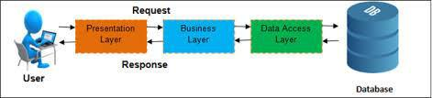

Figure 1: 3-Tier Architecture

**Presentation tier**

This is the topmost level of the application. The presentation tier displays information related to such services as browsing merchandise, purchasing and shopping cart contents. It communicates with other tiers by which it puts out the results to the browser/client tier and all other tiers in the network. In simple terms, it is a layer which user can access directly (such as a web page, or an operating system's GUI).

Application tier (business logic, logic tier, or middle tier)

The logical tier is pulled out from the presentation tier and, as its own layer, it controls an application’s functionality by performing detailed processing.

**Data tier**

The data tier includes the data persistence mechanisms (database servers, file shares, etc.) and the data access layer that encapsulates the persistence mechanisms and exposes the data. The data access layer should provide an API to the application tier that exposes methods of managing the stored data without exposing or creating dependencies on the data storage mechanisms.

Avoiding dependencies on the storage mechanisms allows for updates or changes without the application tier clients being affected by or even aware of the change. As with the separation of any tier, there are costs for implementation and often costs to performance in exchange for improved scalability and maintainability.

### 2.1.3 Comparing different possibilities

**Website Application**

A web app is a collection of related web pages, including multimedia content, typically identified with a common domain name, and published on at least one web server. A website may be accessible via a public Internet Protocol (IP) network, such as the Internet, or a private local area network (LAN), by referencing a uniform resource locator (URL) that identifies the site.

Advantages

➢ Reaching a Wider Audience

➢ Information is accessible to anyone at anytime and anywhere

➢ Cheap advertising

Disadvantages

➢ It crashes up anytime

➢ Maintenance cost

➢ Risk of being hacked

**Native application**

A native mobile app is a smartphone application that is coded in a specific programming language, such as Objective C for iOS or Java for Android operating systems. Native mobile apps provide fast performance and a high degree of reliability.

Advantages

➢ Since native apps work with the device’s built-in features, they are easier to work with and also perform faster on the device.

➢ Native apps get full support from the concerned app stores and marketplaces. Users can easily find and download apps of their choice from these stores.

➢ Because these apps have to get the approval of the app store they are intended for, the user can be assured of complete safety and security of the app.

➢ Native apps work out better for developers, who are provided the SDK and all other tools to create the app with much more ease.

### 2.1.4 Conclusion

Among all the possibilities above, a website has been chosen as the best option for the travel agency

The reasons are as follows:

1. Improve Your Advertising Effectiveness

Placing your website address on all of your promotional material will help you gain additional exposure and encourage the visitors to first check your site for the information they are seeking.

2. Save Money on Printing and Distribution Costs

A website can act as your online brochure or catalog that can be changed or updated at any time. If you employ a content management system (CMS) you can make changes quickly and at no charge.

3. Easy Access to New Customers

You can have your existing customers refer you to their friends and relatives using only your web address or URL.

4. Easy to Use and Update

If maintained properly your website will always be up-to-date and current. Easily make updates, edits and deletions from any computer on the Internet. No more having to pay a programmer every time you want to chance a date or add a product.

5. Improve Productivity

A website increases your company’s productivity because less time is spent explaining product or service details to customers because all this information is available 24 hours a day on your website.

6. Educate Your Customers

Your website can offer free advice about your products and services. This information can be delivered at any hour in a well thought out and consistent way.

7. Expand Your Market

The Internet allows businesses to break through the geographical barriers and become accessible from any of the world by a potential customer that has an Internet connection. Selling products online is cheaper and easier for you and your customers.

8. Extend Your Local Reach

Extend the local reach of your brick-and-mortar store to consumers around the world. You are open for business 24/7 – 365 days/year with all the information the visitors need to make an informed decision.

### 2.1.5 Hardware requirements

|  |  |
| --- | --- |
| RAM | 4GB |
| Storage capacity | 500GB |
| Processor | Core i3 |

### 2.1.6 Software requirements

* XAMPP
* PHP MYADMIN

## 2.2 Operational Feasibility

* The website will allocate enough resources to a customer so that he navigates freely and easily through it.
* Staffs updating the website or working the backend will need half a day training so that they understand the system completely.
* **Process**

Staff and clients using the system will be at ease when using the website as they will be given the opportunity to complete their works within few clicks which leads to less time wastage on choosing their packages. They are also very comfortable with the idea that they do not have to go to a showroom to plan their holiday. They can do it at home taking the amount of time they want to choose the best possible.

* **Performance**

As the website will do their desired works within few clicks, the processing speed will be very much better than doing it manually.

* **Information**

Data integrity should be the website’s first objective as all information displayed on the website should be relevant and updated. Back end user should verify each information displayed everyday as simple mistakes can be big losses for the company.

* **Economy**

The proposed website should be increasing the company’s profits as all customers nowadays look up to such facilities to plan their holidays or trips and as long as a user has internet connection, he will be able to book or plan everything anywhere and anytime regardless to the opening hours of the showroom.

* **Control**

Data security will be another key item of the website as users will register and make payments on the website. So, data should be kept private and confidential or else it will lose its number of users, visits and reliability which will affect the company’s reputation and profit.

* **Efficiency**

Back end users will have to be trained so that they are able to manage the website efficiently and process the bookings of clients.

Staffs will make use of the forms filled by users to process their bookings. All the forms will be arranged in such a way that the staff does not miss any detail of customers while processing bookings.

Only 3 forms will be used for processing all data.

Forms for customers are registration, login and payment. By using only these 3 forms customers should be able to complete all their transactions.

PayPal online payment platform will be used as it is an established, secured and user-friendly payment platform.

* **Services**

The website will offer the following facilities to its customers:

* + Register and login on the website
  + Navigate easily and search for desired products
  + Add items to cart
  + Review cart (add or delete items)
  + Make online payment
  + Request receipt to make payment at the showroom

The vision behind introducing such a system is to offer more services in the future such as

* Hotel room booking
* Activities booking
* Special vehicle rental such as boats, limousines
* Personal assistance during bookings

## 2.3 Economic Feasibility

### 2.3.1 Cost-Benefit Analysis

**Is the project economically possible?**

The budget of the company is around Rs 150,000. The cost of the project is in the range of the of the client’s budget as his budget was around Rs 250,000.

**Is the proposed system being effective enough?**

The proposed system is effective since with the increase number of online customers each year, the margin of profit keeps on increasing. (During a survey conducted in 2017, 40 percent of internet users in the United States stated that they purchased items online at several times per month, and 20 percent said they bought items or services online on a weekly basis.) Many companies are investing lots of money to develop their own web stores to sell their product.

In addition to that, the Web Application will be running 24/7, hence there is almost no barriers between online customers and the web application.

**What are the savings that will be done using this proposed solution?**

• With a Web Application, the business owner does not have to look for several places ti open his showrooms and employ more staff as online applications saves a lot of money. If the customers are satisfied, they may do the website marketing by recommend it to another person (e.g. relatives, friends or colleagues).

• The Web Application will be running 24/7, hence this could result in additional revenue as well as energy savings

**Do the proposed system’s benefits outweigh the investment cost?**

The proposed system will be developed using the technologies that are open-source as described in the technical feasibility. In this proposed system, since most of the technologies used are free, this impact positively on the capital cost of the project, hence the benefits outweigh the cost. For the users to access the application, the only cost involved will be in getting access to the Internet.

### 2.3.2 Payback Period

Capital Cost – Rs 149681

Recurrent Cost – Rs 35000

**What benefits will result from the system?**

### 2.3.2.1 Tangible Benefits

* Improved speed of processing
* Improved accuracy of processing
* Improved efficiency and productivity of staffs
* Increased revenues from sales

### 2.3.2.2 Intangible Benefits

* Improved customer satisfaction
* Improved customer loyalty
* Improved sales forecasting
* Improved purchasing information
* Improved production scheduling

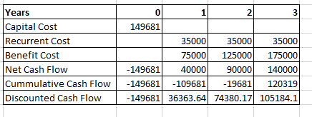

Figure 2: Payback Period

The payback period is estimated to be in Year 1 that is it has a low financial risk.

• The Discounted rate used is 10%.

• NPV was found to be 66246.87 when the summation of the discounted cash flow was calculated. Since NPV > 0, it is profitable.

## 2.3.3 Sensitivity analysis

#### Scenario 1

**Capital Cost is increased by 10%. New Capital Cost is MUR 164649.1**

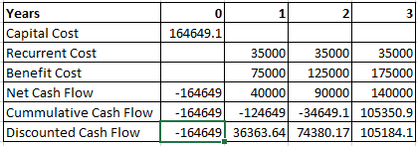

Figure 3: Sensitivity Analysis Scenario 1

#### Scenario 2

Recurrent Cost is increased by 10%. New Recurrent cost is MUR 38500

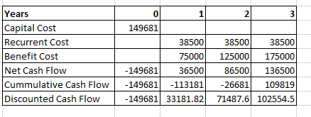

Figure 4: Sensitivity Analysis Scenario 2

## 2.3.4 Conclusion:

Since both NPV percentage in the scenario shown above are less than 20% therefore, it can be concluded that Capital Cost and Recurrent Cost are not sensitive.

Chapter 3: Methodology

# 3.0 Chosen Methodology

## 3.1 Agile methodology

Agile software development refers to a group of software development methodologies based on iterative development, where requirements and solutions evolve through collaboration between self-organizing cross-functional teams. Agile methods or Agile processes generally promote a disciplined project management process that encourages frequent inspection and adaptation, a leadership philosophy that encourages teamwork, self-organization and accountability, a set of engineering best practices intended to allow for rapid delivery of high-quality software, and a business approach that aligns development with customer needs and company goals. [Agile development](https://www.cprime.com/2016/03/what-is-agile-product-development/) refers to any development process that is aligned with the concepts of the Agile Manifesto. The Manifesto was developed by a group fourteen leading figures in the software industry and reflects their experience of what approaches do and do not work for software development.

## 3.2 Agile software development principles

1. Customer satisfaction by early and continuous delivery of valuable software
2. Welcome changing requirements, even in late development
3. Working software is delivered frequently (weeks rather than months)
4. Close, daily cooperation between business people and developers
5. Projects are built around motivated individuals, who should be trusted
6. Face-to-face conversation is the best form of communication (co-location)
7. Working software is the primary measure of progress
8. Sustainable development, able to maintain a constant pace
9. Continuous attention to technical excellence and good design
10. Simplicity—the art of maximizing the amount of work not done—is essential
11. Best architectures, requirements, and designs emerge from self-organizing teams
12. Regularly, the team reflects on how to become more effective, and adjusts accordingly

## 3.3 Advantages of Agile model:

* Customer satisfaction by rapid, continuous delivery of useful software.
* People and interactions are emphasized rather than process and tools. Customers, developers and testers constantly interact with each other.
* Working software is delivered frequently (weeks rather than months).
* Face-to-face conversation is the best form of communication.
* Close, daily cooperation between business people and developers.
* Continuous attention to technical excellence and good design.
* Regular adaptation to changing circumstances.
* Even late changes in requirements are welcomed

## 3.4 Disadvantages of Agile model:

* In case of some software deliverables, especially the large ones, it is difficult to assess the effort required at the beginning of the software development life cycle.
* There is lack of emphasis on necessary designing and documentation.
* The project can easily get taken off track if the customer representative is not clear what final outcome that they want.
* Only senior programmers are capable of taking the kind of decisions required during the development process. Hence it has no place for newbie programmers, unless combined with experienced resources.



Chapter 4: Planning

# 4.0 Project Planning

## 4.1 Gantt Chart

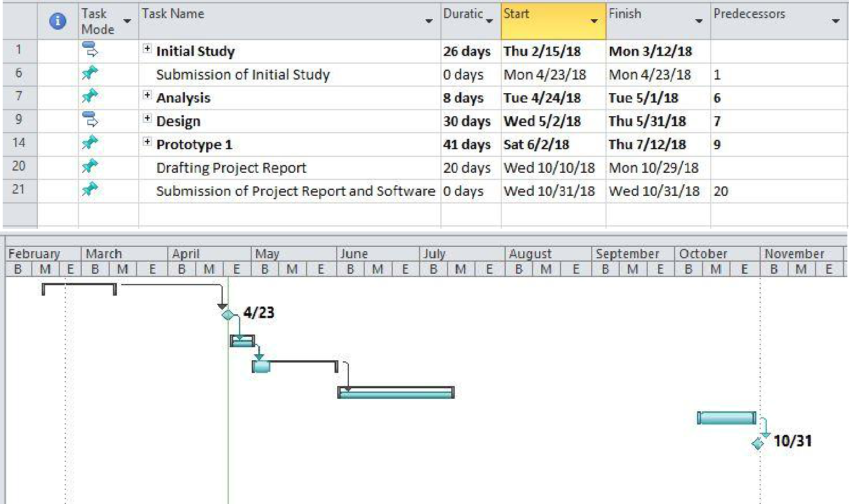

Figure 5: Gantt chart part (1)

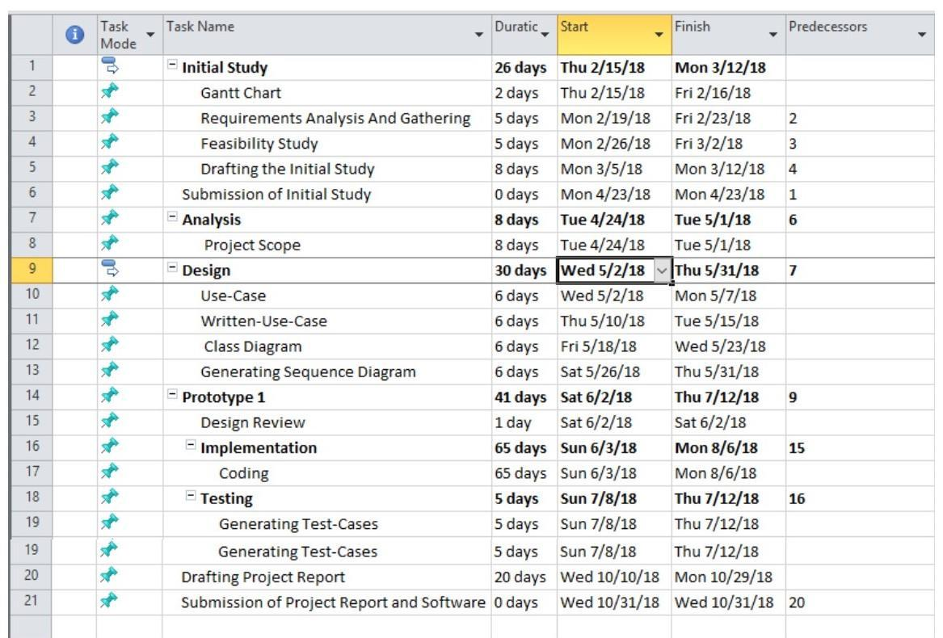

Figure 6: Gantt chart part(2)

## 4.2 Work Breakdown Structure (WBS)

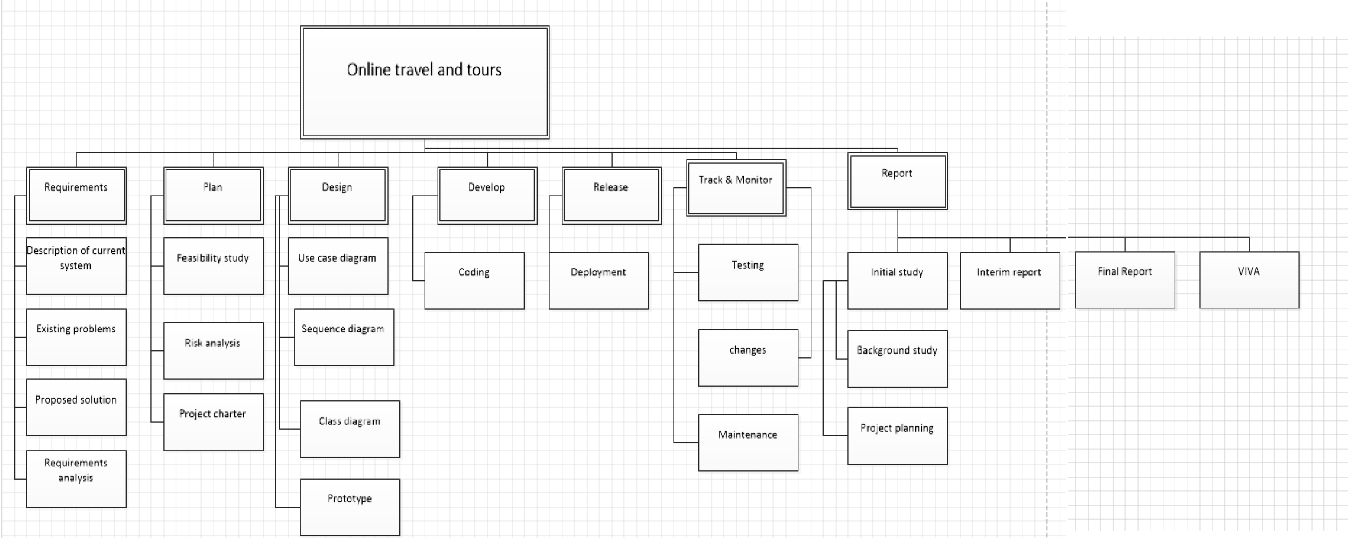

Figure 7: Work Break down Structure

## 4.3 Project Charter

The aim of this project is to reduce customers visit to the agency and provide them with a better-quality service where they can take all the required time to plan their trip. The aims identified are to help the travel and tours agency to do the following:

* Verify every available item
* Record requested items such as flights, trips or vehicles
* Record and update customer details
* Record and update trips
* Eliminate use of paper work
* Provide a secure and reliable system so that confidential information is not disclosed to unauthorized people
* Provide a system which can be upgraded later depending on if the requirements or way of proceedings change
* Ensure whether data can be accessed whenever required
* Fast and efficient data handling

## 4.4 Project Scope

The admin can:

* Add new flights, trip packages, vehicles to rent and payments
* Add and update trip, package or car rental details
* Keep track of customers payments
* Remind patient of payment in case showroom payment selected
* Update a package of a customer on his request
* Cancel a customer’s order

The user can:

* Register and login
* Modify personal details
* Search for items in accordance to a date
* Make online payment
* Request receipt to make cash payment at the showroom

The admin can:

* Process orders and data
* Update the website contents
* Verify the payments status

The system will:

* Save all data in database

### 4.4.1 Importance of the project

* Unauthorized people will not be able to manipulate data or customer details
* Information will be retrieved easily hence faster processing and service
* Easier way to update information
* Services will be available 24/7
* Accessible to a very big percentage of the market

Chapter 5: Requirement Analysis

# 5.0 Requirement Analysis

## 5.1 Functional Requirement

* Customers must be able to register
* Customers must be able to login
* Customer must be able to modify profile in case of personal changes
* Customers must be able to navigate the page without login
* Customers must be able to search
* Customers must be able to add items to cart
* Customers must be able to modify cart
* Customers must be able to make online payment
* Customers must be able to make showroom payment on request
* Customers must be able to contact agency via the contact page
* Customers must be able to give feedback
* Admin must be able to update website contents
* Admin must have all customers details
* Admin must be able to receive customer orders
* Admin must be able to process orders
* Admin must be able to receive e-mails from customers (sent from a form in the contact page)
* Admin must be able to receive feedback from customers (sent from a form in the contact page)

## 5.2 Non-Functional Requirement

* Maintainability- Ease to correct errors if encountered
* Speed-Normalized tables channeled for a particular task increases the speed at which the data is processed in the database
* Security-Each table in the database will have authentication whereby online users with required permission will be able to access it
* Integrity-Data will be kept to a high-level security so as to prevent attacks which can harm the data integrity of the website. This means that data will be kept secure an up to date
* User friendliness-the website must be designed in such a way that all users of the website do not have any difficulty at all in managing or using the website

Chapter 6: Design

# 6.0 Design

## 6.1 Database design

### 6.1.1 ERD

Figure 8: ERD - Physical

### 6.1.2 Class Diagram

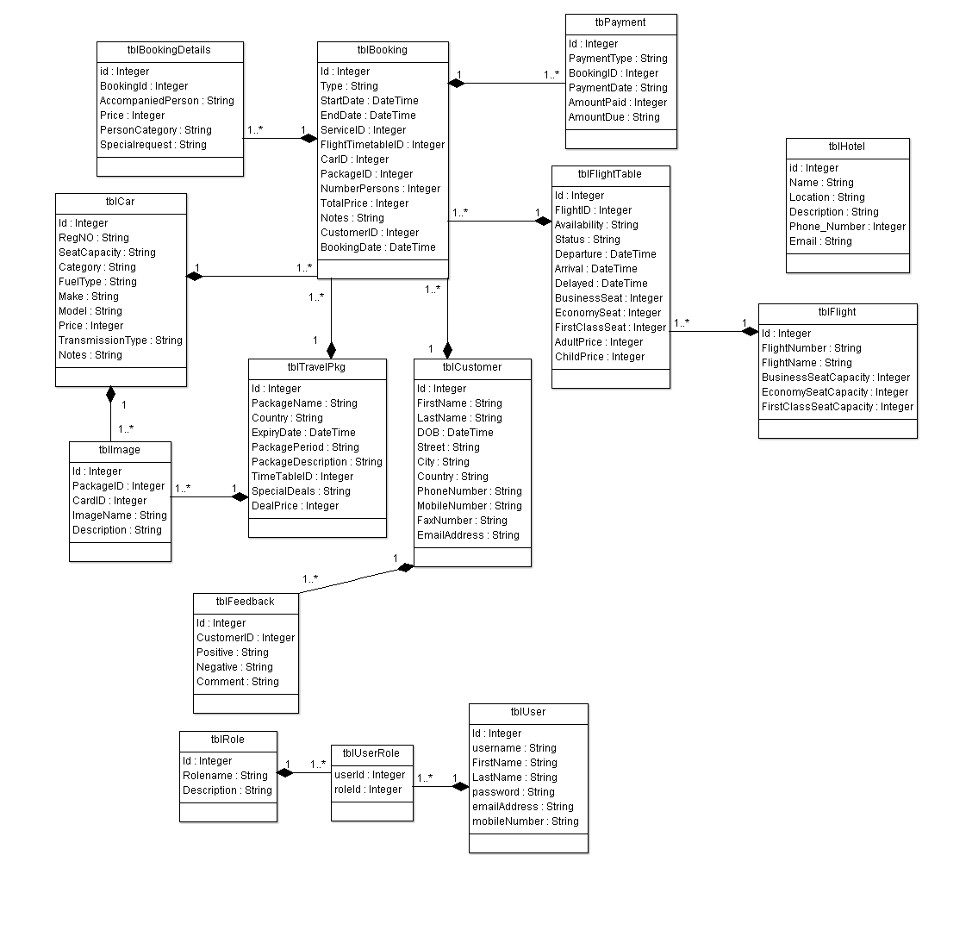

Figure 9: Class Diagram

### 6.1.3 Use case diagram

Figure 10: Use Case Diagram

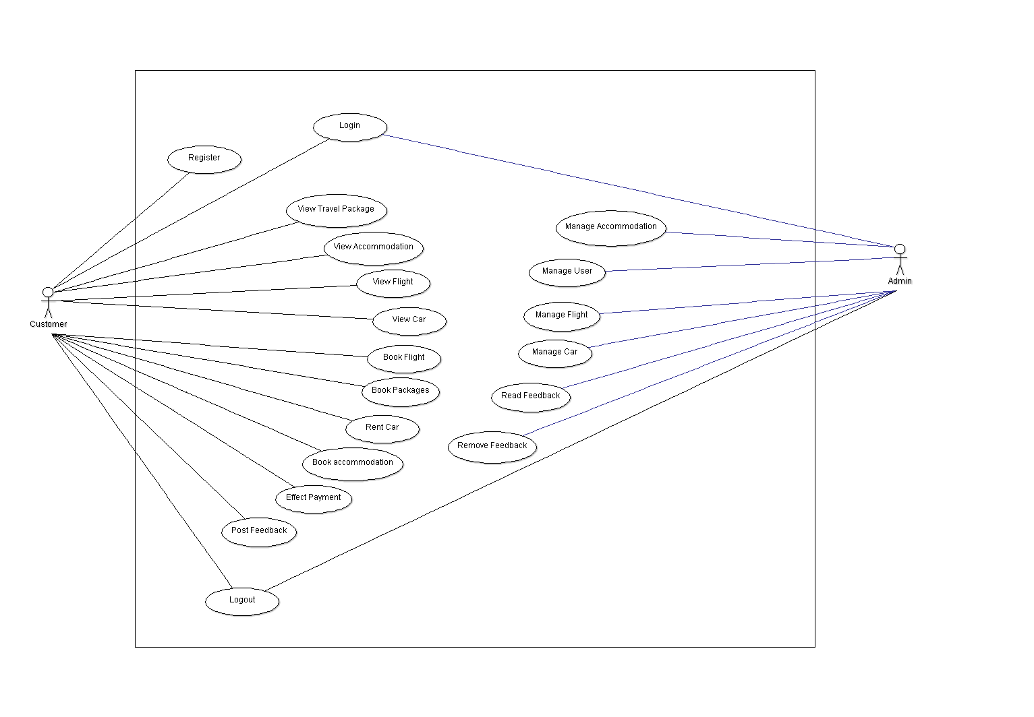

**Online Travel Tours & Agency**

### 6.1.3.1 Use Case Specification

|  |  |
| --- | --- |
| Use Case: | Online Travel Tours & Agency |
| Actor | Customer, Admin |
| Precondition | User is not yet registered |
| Flow of events: |  |
| Actor Action | System response |
| * Customer fills registration form * Customer login * Customer search for packages, accommodations, flights or car rental * Customer post a feedback * Customer book an accommodation, flight, car or package * Customer effect payment * Customer log out * Admin login * Admin edits Accommodation * Admin edits Flights * Admin edits Packages * Admin edits Car * Admin block/unblock users * Admin clicks on log out | * System verifies inputs and register user if correct * System verifies credentials and sign in customer * System searches for given data * System submit feedback * System add a new booking for customer * System effects payment of booking by customer * System remove session for that particular user and log the latter out of the application * System verifies credentials and redirect admin to dashboard * System update accommodation information and returns a success message if correct * System update flight data and returns a success message if correct * System update package data and returns a success message if correct * System update car data and returns a success message if correct * System block or unblock user * System destroy admin session and log the latter out of the system |

### 6.1.4 Data Dictionary

|  |  |  |  |  |  |
| --- | --- | --- | --- | --- | --- |
| Table Name | Column Name | Data Type | Field Length | Constraint | Value |
|  | | | | | |
| Tbl_airline | Id | Integer | 11 | PK – Not Null |  |
| airline | Varchar | 50 | Null |  |
| description | DateTime | - | Null |  |
|  | | | | | |
| Tbl_car_rental_company | Id | Integer | 11 | PK – Not Null |  |
| company | Varchar | 50 | Not Null |  |
| description | Varchar | 50 | Not Null |  |
|  | | | | | |
| Tbl_cart | Id | Integer | 11 | PK -Not Null |  |
| user | Integer | 11 | Not Null |  |
|  | | | | | |
| Tbl_cart_order | Id | Integer | 11 | PK – Not Null |  |
| Cart_id | Integer | 11 | Not null | FK |
| Order_id | integer | 11 | Not null | FK |
|  | | | | | |
| Tbl_car_rental | Id | Integer | 11 | PK – Not Null |  |
| Car_title | Varchar | 50 | Null |  |
| Car_rental_company | varchar | 11 | Null |  |
| Pickup_id | Integer | 11 | Null |  |
| Transmission | varchar | 50 | Null |  |
| price | Numeric | (18,0) | Null |  |
|  | year | Integer | 11 | PK – Not Null |  |
| freeDelivery | Varchar | 50 | Null |  |
| Discount_id | Varchar | 200 | Null |  |
| conditionApply | Varchar | 200 | Null |  |
| dateFrom | date | 11 | Null |  |
| dateTo | date | 11 | Null |  |
|  | | | | | |
|  | | | | | |
|  | | | | | |
| Tblcar_rental_gallery | Gallery_id | Integer | 11 | PK – Not Null | FK |
| Car_rental_id | integer | 11 | Null | FK |
|  | | | | | |
| Tbl_country | Id | Integer | 11 | PK – Not Null |  |
| Country_code | Varchar | 50 | Not Null |  |
| Country_name | Varchar | 50 | Not null |  |
|  | | | | | |
| Tbldays | Id | Integer | 11 | PK – Not Null |  |
| days | Varchar | 11 | Not null |  |
|  | | | | | |
| Tbldiscount | Id | Integer | 11 | PK – Not Null |  |
| Discount_percent | Integer | 11 | Not null |  |
|  | | | | | |
| Tblgallery | Id | Integer | 11 | PK – Not Null |  |
|  | imagePath | Varchar | 50 | Not null |  |
|  | | | | | |
| Tblhotel | Id | Integer | 11 | PK – Not Null |  |
|  | hotelName | varchar | 25 | Null |  |
|  | Price | Integer | 1 | Null |  |
|  | dateFrom | Date | 11 | Null |  |
|  | dateTo | Date | 11 | Not Null |  |
|  | purchaseInclude | Varchar | 200 | Null |  |
|  | packageDetails | Varchar | 20022 | Null |  |
|  | Discount_id | integer |  | Not null |  |

|  |  |  |  |  |  |
| --- | --- | --- | --- | --- | --- |
| Tbl_hotel_gallery | Gallery_id | Integer | 11 | Not Null | FK |
| Hotel_id | integer | 11 | Not null | FK |
|  | | | | | |
| Tbl_meal_type | Id | Integer | 11 | PK – Not Null |  |
| Meal_type | Varchar | 50 | Not Null |  |
| Price | integer | 11 | Null |  |
|  | | | | | |
| Tbloccupacy | Id | Integer | 11 | PK – Not Null |  |
| occupacy | Varchar | 10 | Null |  |
|  | Occupancy_value | integer | 3 |  |  |
|  | | | | | |
| Tbl_ordercarrental | Id | Integer | 11 | PK – Not Null |  |
| Car_rental_id | Integer | 11 | Not null | FK |
|  | No_of_days | Integer | 11 | Not null |  |
|  | Total_price | Integer | 11 | Not null |  |
|  | Order_category | varchar | 11 | Not null |  |
|  | | | | | |
| Tblorderpackage | Id | Integer | 11 | PK – Not Null |  |
|  | Hotel_id | Integer | 11 | Not null | FK |
|  | Room_type_id | Integer | 11 | Not Null | FK |
|  | Occupacy_id | Integer | 11 | Not Null | FK |
|  | Meal_type_id | Integer | 11 | Not Null | FK |
|  | Check_in | date | 11 | Not Null |  |
|  | Checkout | date | 11 | null |  |
|  | nights | integer | 5 | null |  |
|  | Order_category | varchar | 50 | Not null |  |
|  | Total_price | Integer | 11 | Not Null |  |
|  | | | | | |
| Tblhotel | Id | Integer | 11 | PK – Not Null |  |
|  | hotelName | Integer | 11 | Not null |  |
|  | Price | integer | 11 | Null |  |
|  | dateFrom | date | 11 | Not null |  |
|  | dateTo | date | 200 | Not Null |  |
|  | purchaseInclude | Varchar | 200 | Null |  |
|  | packageDetails | Varchar | 200 | Null |  |
|  | | | | | |
| Tblhotel | Id | Integer | 11 | PK – Not Null |  |
|  | Package_type_id | Integer | 11 | Null | References tblCustomer(Id) |
|  | Total_price | Char | 1 | Null |  |
|  | checkin | Char | 1 | Null |  |
|  | Package_id | Varchar | 200 | Not Null |  |
|  | Order_category |  |  |  |  |
|  | Room_type_id |  |  |  |  |
|  | Meal_type_id |  |  |  |  |
|  | Occupancy_id |  |  |  |  |
|  | Full name |  |  |  |  |
|  | Departure_date |  |  |  |  |
|  | Return_date |  |  |  |  |
|  | pax_adult |  |  |  |  |
|  | paxteen |  |  |  |  |
|  | Pax_infant |  |  |  |  |
|  |  |  |  |  |  |
|  |  |  |  |  |  |

|  |  |  |  |  |  |
| --- | --- | --- | --- | --- | --- |
|  | | | | | |
| Tblpackage | Id | Integer | 11 | PK – Not Null |  |
|  | Package_title | Varchar | 11 | Null |  |
|  | price | Integer | 1 | Null |  |
|  | Discount_id | Char | 1 | Null | FK |
|  | Purchase include | Varchar | 200 | Not Null |  |
|  | OpackageDetails | Varchar |  |  |  |
|  | DateFrom | date |  |  |  |
|  | dateTo | date |  |  |  |
|  | Cover_image |  |  |  |  |
|  | packageType_id | Integer |  |  |  |
|  | Country_id | Integer |  |  |  |
|  | terms | Varchar |  |  |  |
|  | Airline_id | Integer |  |  |  |

|  |  |  |  |  |  |
| --- | --- | --- | --- | --- | --- |
|  | | | | | |
| Tblpackage_type | Id | Integer | 11 | PK – Not Null |  |
|  | Package_type | Integer | 11 | Not null |  |

|  |  |  |  |  |  |
| --- | --- | --- | --- | --- | --- |
|  | | | | | |
| Tblpickip_point | Id | Integer | 11 | PK – Not Null |  |
|  | Pickup_place | Integer | 11 | Not null |  |

|  |  |  |  |  |  |
| --- | --- | --- | --- | --- | --- |
|  | | | | | |
| Tblroom_type | Id | Integer | 11 | PK – Not Null |  |
|  | Room_type | Integer | 11 | Not null |  |
|  | Price | Char | 1 | Not null |  |

|  |  |  |  |  |  |
| --- | --- | --- | --- | --- | --- |
|  | | | | | |
| Tbluser | Id | Integer | 11 | PK – Not Null |  |
|  | Firstname | Varchar | 11 | Null |  |
|  | Last_name | Varchar | 1 | Null |  |
|  | Email | Varchar | 1 | Null |  |
|  | Password | Varchar | 200 | Not Null |  |
|  | gender | Varchar | 6 | Not Null |  |
|  | country | Varchar | 12 | Not Null |  |
|  | phone | Integer | 12 | Not Null |  |
|  | roletype | Varchar | 11 | Not Null |  |
|  | status | Integer | 1 | Not Null |  |

## 6.2 User Interface Design

### Customer Section

#### Home Page

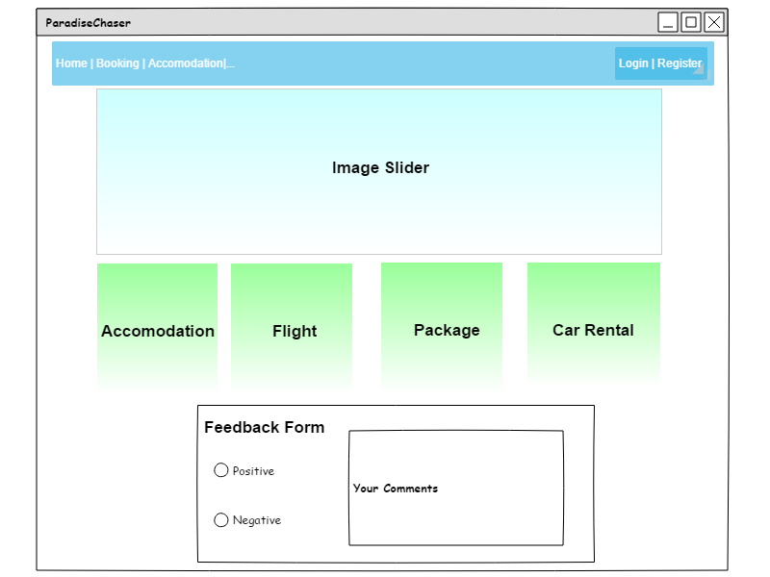

Figure 11: Homepage interface design

#### Register

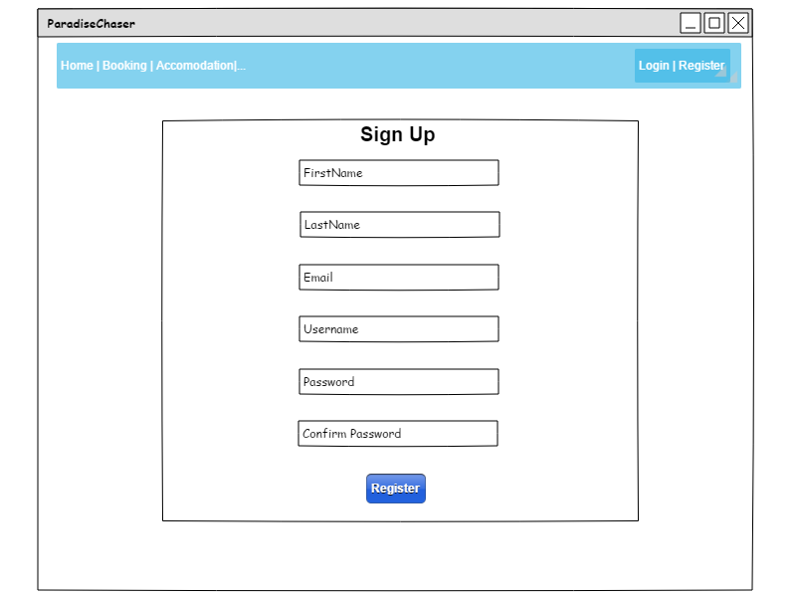

Figure 12: Register interface design

#### Login

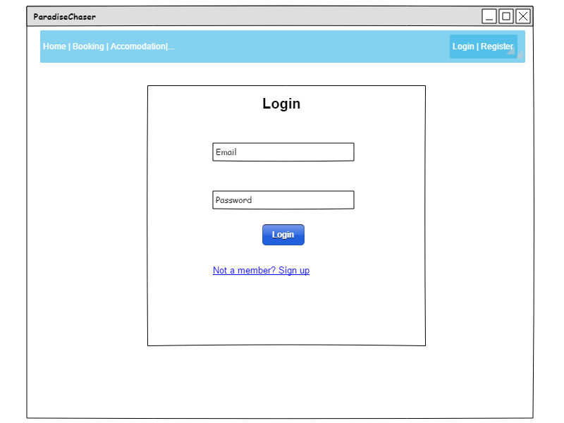

Figure 13: Login interface design

#### Book Accommodation Page

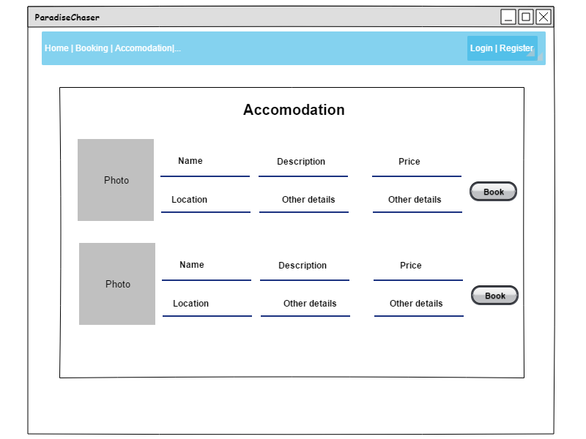

Figure 14: Book Accomodation interface design

#### Book Flights Page

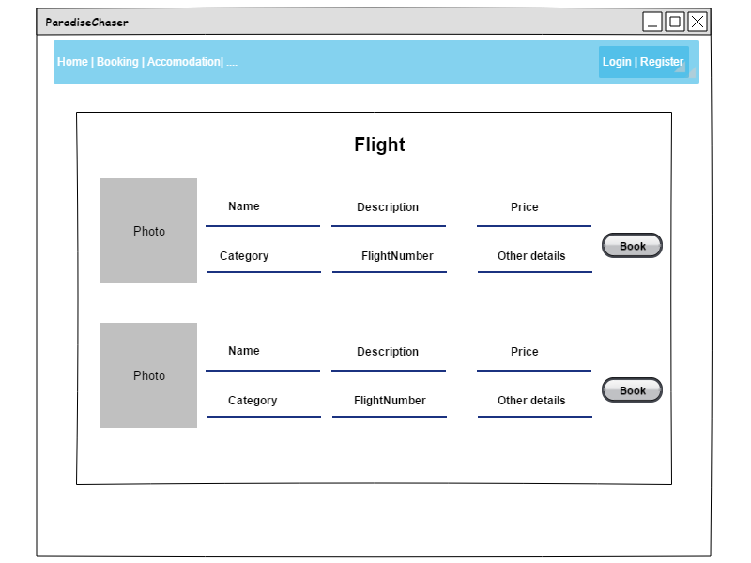

Figure 15: Flight interface design

#### Car Rental Page

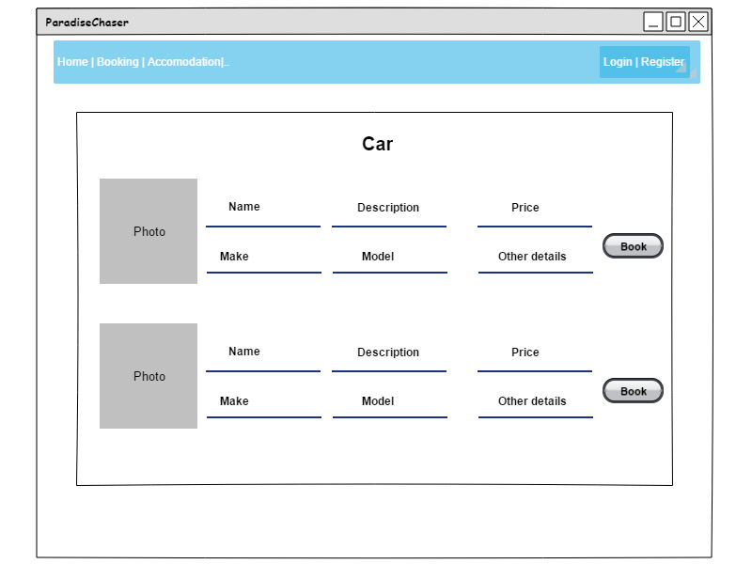

Figure 16: Car rental interface design

### Admin Section

#### Crud operations

Figure 17: Manage Flight, Accommodations, Car interface design

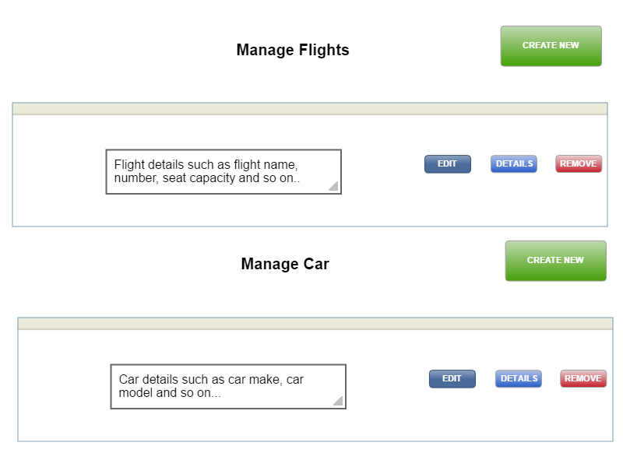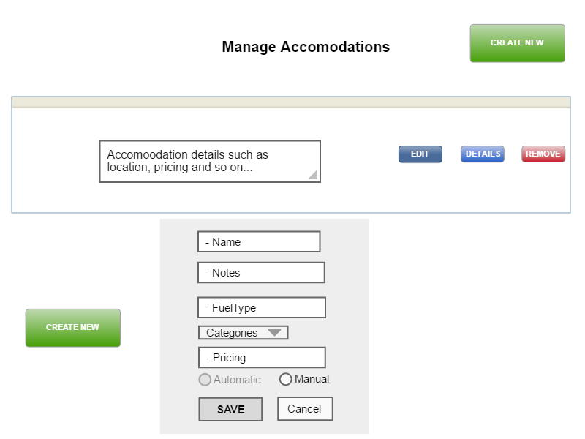

Upon clicking on the create new button, the user is redirected to the following form:



Figure 18: CRUD - Create New interface design

Chapter 7: Implementation

# 7.0 Implementation

Plugins Used for Paradise Chaser Development

1. Bootstrap 4.0.0

2. PHP

3. Mysql

4. HTML, CSS

5. JQuery

6. JavaScript

7. FlatPickr Datepicker

8. Jquery form validation

9. Bootstrap Datatable

10. Jquery Zoom image effect

11. Slick JS For slider effect

12. Bootstrap Datepicker

This project was developed using VSCode editor, PHP 7 and MySQL database

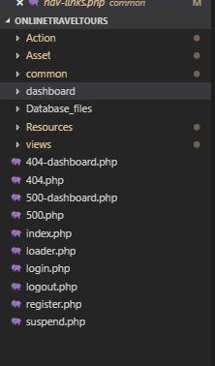**Folder structure**

Action: This file contains all the php scripts required for the functionality of the website.

Asset: The common file contains the front-end part of the website i.e. the JS, CSS, fonts and images used.

Common: The folder common contains the common elements found on the webpages in order to prevent code duplications

It consists of the header, footer both by admin and customer interface

Dashboard: the dashboard folder contains all admin pages as well as all uploaded images onto the site

View: The folder view contains all the webpages of the web applications of the user interface section.

**Coding structure**

Reducing code duplication

External php files were used in order to eliminate code duplication for example:

1. An icon file was created so that any icon created becomes reusable
2. A nav-link file was created to link all pages and links and making them remains in their correct paths as shown below:

Nav links PHP

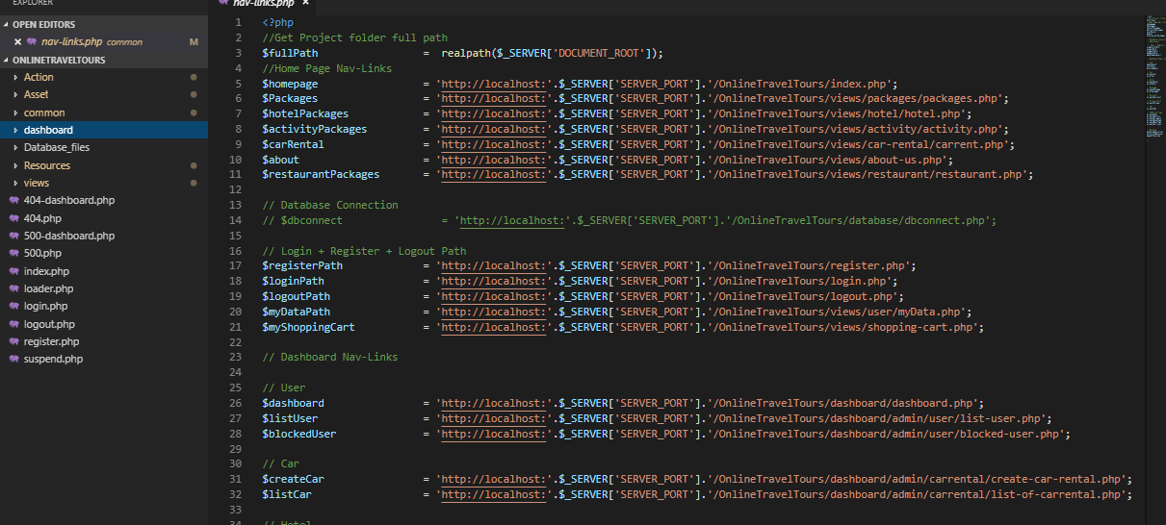

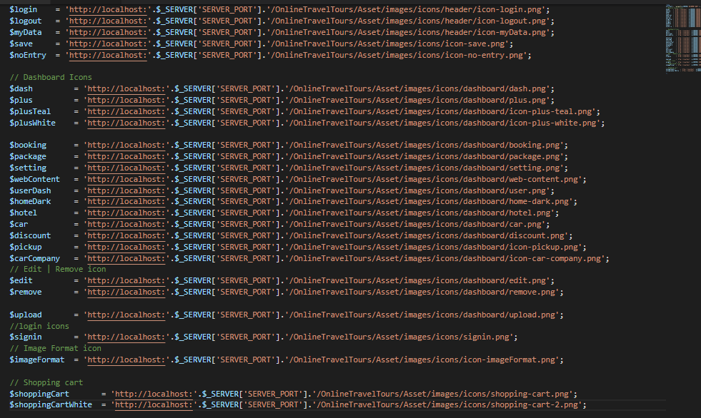Icons PHP

1. Error pages

2 error pages was developed namely page 404 and page 500

404 – will appear If ever page Is not found/ items not found

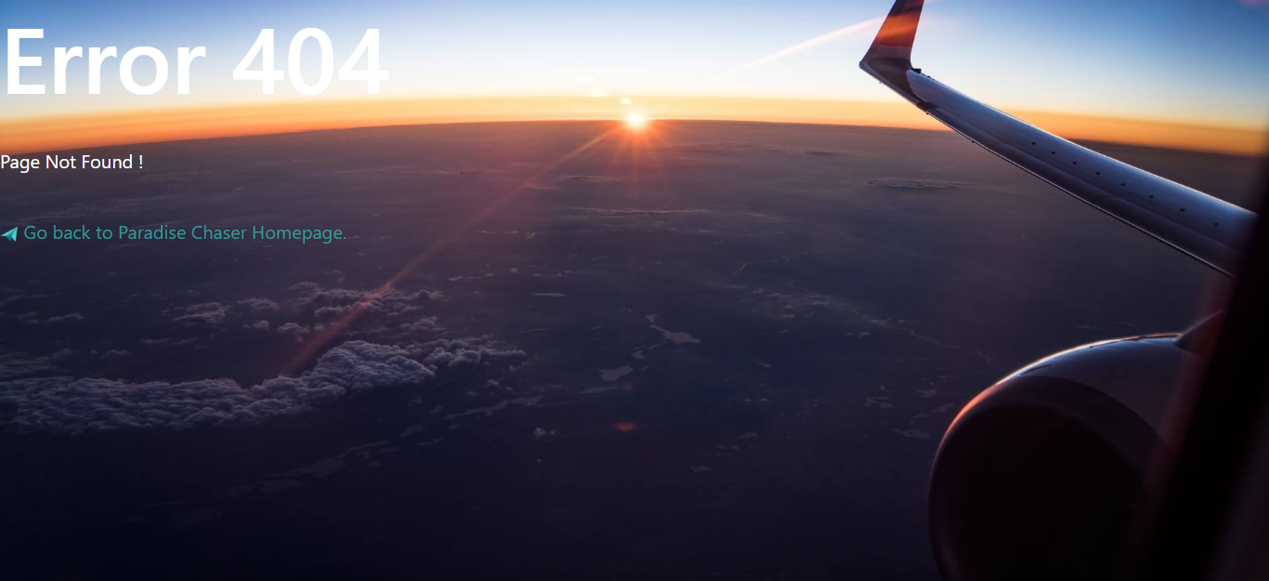

500- will appear if ever there is an issue on the database part or the site has been down i.e. server error

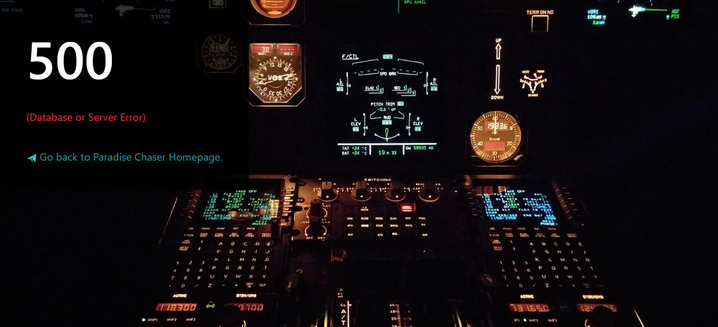

Chapter 8: Testing

# 8.0 Testing

## 8.1 Whitebox testing

White-box testing complements unit testing and integration testing. Given below ParadiseChaser test case:

|  |
| --- |
| Pre-conditions: Tester should have knowledge of the   * Internal coding about the web application (e.g. programming language used) * How to make use of a web application. * Tester must understand the inner working of the system. |

|  |  |  |  |  |  |
| --- | --- | --- | --- | --- | --- |
| Step No. | Test Cases | Test Data | Expected Result | Actual Result | Status |
| 1. | Customer sign up |  | Customer must be able to create an account upon clicking on sign-up button. | A sign-up form page is displayed to user on a page. | Passed  Failed |
|  |  |  | Upon clicking on the register button, user must register into the system. | A success message is shown and user is successfully registered into the system | Passed  Failed |
|  | Registering a new customer | FirstName =’John’  LastName =’Smith’ | Firstname and lastname accepted | User can make use of this firstname and lastname | Passed  Failed |
|  |  | Username =’John123’ | Username accepted | Customer can make use of this username | Passed  Failed |
|  |  | Username =’John123’ | Username not accepted | Error message is displayed as username already exists. | Passed  Failed |
|  |  | Email = ‘1234’  Email = ‘john@’ | Error message showing invalid email entered. | Error message for invalid email and a pop up appears for tip. | Passed  Failed |
|  |  | Email= johnsmith@gmail.com’ | No error message, correct email entered. | Message displayed as Valid email address | Passed  Failed |
|  |  | Password = ‘abcd123  Password = ‘abcd’ | Display error message. | Error message is displayed showing password too short. | Passed  Failed |
|  |  | Password = ‘hello12345678’ | Display error message. | Password must consist of an upper-case letter. | Passed  Failed |
|  |  | Password = ‘SecurityCode20181!  Confirm password =’’ | No error message for, password text field but error message in confirm password. | Please fill out confirm password field. | Passed  Failed |
|  |  | Password = ‘helloworld20181!’  Confirm Password = ‘helloworld20181!’ | No error message displayed.  Correct password and confirm password. | Password and Confirmed Password fields does not match | Passed  Failed |
|  |  | All fields empty | Error message displayed for each field. | Error message is displayed under each field and are highlighted in red color. | Passed  Failed |
|  | | | | | |
| 2. | Customer login |  |  |  | Passed  Failed |
|  |  |  | Customer must be able to log into the application upon clicking on the sign-in button. | A login page is displayed to user asking for login credentials (username & password). | Passed  Failed |
|  |  |  | Customer must be able to enter login credentials. | Customer is redirected to homepage after successfully logged in.  A navigation bar is displayed with the different options available such as home, flights, accommodations, logout and so on.  Customer session is created and will be close when the user logout from the system. | Passed  Failed |
|  | Login for a registered customer | Email = “John123@gmail.com”  Password = “John1!” | User successfully login.  User is redirected to homepage. | User logs in.  User is redirected to respective homepage. | Passed  Failed |
|  | Customer entering wrong credentials in the login form. | Email = “jogn12@yahoo.com”  Password = “abcd1!” | Error message is displayed.  User is notified that account does not exit. | Error message is displayed. | Passed  Failed |
|  | Customer entering blank values in the login form. | Email = “”  Password =”” | Error message is displayed. | Error message is displayed stating to fill in the required fields. | Passed  Failed |
|  | | | | | |
| 3. | Customer view packages |  | Customer must be able to view a list of travel packages | Upon clicking on the packages card from the homepage, a list of all packages available are displayed to user. | Passed  Failed |
| 4. | Customer book flight |  | Customer click on flights from the homepage or navigation area.  Customer must be able to book a flight | Customer view flight details.  Customer click on book button in order to book flight | Passed  Failed |
| 5. | Customer rent a car |  | Customer click on flights from the homepage or navigation area.  Customer must be able to rent a car | Customer gets car available.  Customer click on the rent car button in order to rent a car | Passed  Failed |
| 6. | Customer make payment |  | Customer make payment for item book | Customer is redirected to payment form to complete payment transaction | Passed  Failed |
| 7. | Customer view accomodations |  | Customer must be able to view list of accommodation i.e. hotels available. | Upon clicking on the accommodation link from the navigation area or the home page, customer is redirected to accommodation page and have a list of all available hotels. | Passed  Failed |
| 8. | Customer book an accomodation |  | Customer must be able to book a hotel for his/her accommodation | Hotel is book upon clicking on the book button found in the accommodation page. | Passed  Failed |
| 9. | Customer book a package |  | Customer must be able to book a package on the website | Customer clicks on the package link from the home page and us redirected to the package list.  Upon clicking on the book package button, customer has successfully booked a package. | Passed  Failed |
| 10. | Customer can post a feedback | Customer must be able to post a review on the company. | User must go to the bottom of the homepage and have the ability to post a feedback.  . | Customer feedback is successfully posted.  The latter cannot post more than 1 feedback. | Passed  Failed |
| 11. | User submit empty feedback | Positive = ‘’  Negative =’’  Comments = ‘’ | Error message is shown. | Please fill up the required fields. | Passed  Failed |
| 12. | User submit a proper feedback | Positive checked  Negative = ‘’  Comments =’This is a positive review’ | No error message is displayed. | Feedback has been successfully posted. | Passed  Failed |
|  | | | | | |
| 13. | Admin login |  | Admin must be able to able to enter registered credentials to login to ParadiseChaser dashboard. | Upon successful login, admin dashboard is displayed.  Admin name is appeared on the page.  Admin logout button is displayed on the page. | Passed  Failed |
|  | | | | | |
| 14. | Admin manages users |  | Admin must be able to view all the list of users using the system. | Admin can access the list of users. | Passed  Failed |
|  |  |  | Admin must be able to block a user | Upon clicking on the block button, user is successfully blocked. | Passed  Failed |
|  |  |  | Admin must be able to unblock a user | Upon clicking on the block button, user is successfully unblocked. | Passed  Failed |
|  | | | | | |
| 15. | Admin manages accommodations |  | Admin must be able to view all list of available accommodations | Upon clicking on the view accommodations, Admin can access all the accommodations available | Passed  Failed |
|  |  |  | Admin must be able to update an accommodation | Upon clicking on the update button, a form is displayed to the user and the latter is prompted to change values as required. Item is successfully updated. | Passed  Failed |
|  |  |  | Admin must be able to remove an accommodation | Upon clicking on the remove button, an alert message is shown in order to confirm removal of item. Item is successfully removed. | Passed  Failed |
|  |  |  | Admin must be able to create a new accommodation | Upon clicking on the create new button, a form is shown to create a new accommodation. A new accommodation is successfully created. | Passed  Failed |
|  | | | | | |
| 16. | Admin manages flights |  | Admin must be able to view all list of available flights | Upon clicking on the view accommodations, Admin can access all the flights available | Passed  Failed |
|  |  |  | Admin must be able to update a flight | Upon clicking on the update button, a form is displayed to the user and the latter is prompted to change values as required. Item is successfully updated. | Passed  Failed |
|  |  |  | Admin must be able to remove a flight | Upon clicking on the remove button, an alert message is shown in order to confirm removal of item. Item is successfully removed. | Passed  Failed |
|  |  |  | Admin must be able to create a new flight | Upon clicking on the create new button, a form is shown to create a new flight. A new flight is successfully created. | Passed  Failed |
|  | | | | | |
| 17. | Admin manages car rental |  | Admin must be able to view all list of car rental by customers | Upon clicking on the view car rental, Admin can access all the car for rent available | Passed  Failed |
|  | | | | | |
| 18. | Admin manages cars |  | Admin must be able to view all list of available cars | Upon clicking on view cars, a list of all available cars for rent are displayed to admin. | Passed  Failed |
|  |  |  | Admin must be able to update a car | Upon clicking on the update button, form is populated and displayed to user.  User is prompted to change data as required.  Car has been successfully updated. | Passed  Failed |
|  |  |  | Admin must be able to remove a car | Upon clicking on the remove button, car is successfully removed from the system | Passed  Failed |
|  |  |  | Admin must be able to create a new car | Upon clicking on the create new car button, a form is displayed asking to enter data.  After success form filling, a new car is created. | Passed  Failed |
|  | | | | | |
| 19. | Admin view feedbacks/reviews |  | Admin must be able to remove abusive feedbacks from customers | Feedback is successfully removed upon clicking on the remove button. | Passed  Failed |

## 8.2 Black Box testing

Black box testing is a software testing technique that focuses on the analysis of software functionality, versus internal system mechanisms. Black box testing was developed as a method of analyzing client requirements, specifications and high-level design strategies.

|  |  |  |  |
| --- | --- | --- | --- |
| Pre-conditions:   * Tester should know how to handle a web application and functioning of it. * Web application should be in working condition i.e. fully implemented locally | | | |
| Step No. | Test Cases | | Test Data | Expected Result | Actual Result | | Status |
| 1. | Fill out the registration form completely and click on the register button | | Click on sign-up  Enter all required fields  Click on sign up button | If all inputs is correct, and complete so user should be registered | Working as expected | | Passed  Failed |
| 2. | Check if edit button works on the accommodation page | | Click on the edit button in the accommodation page in the admin section | If data has been updated without errors, then the edit button is working. | Working as expected | | Passed  Failed |
| 3. | Check if register button works | | Click on the register button in the sign-up page | If success message appears once customer clicks on the register button, it means that the customer has been successfully registered into the web application | Working as expected | | Passed  Failed |
| 4. | Check if logout button works | | Click on the logout button found on your navigation bar | If user is logged out from the system and all session are destroyed for that user, it means the logout button is working. | Working as expected | | Passed  Failed |
| 5. | Check if Remove button works in the admin section for removing a car from the system | | Click on the remove button for car in the admin section | If message is shown stating that item has been removed successfully, then remove button is working | Working as expected | | Passed  Failed |
| 6. | Check if customer can login properly | | Click on the login button from the navigation area and enter login credentials for a customer | Customer must be redirected to homepage but with a different navigation area i.e. the customer name must be seen on the navigation bar as well as the logout button | Working as expected | | Passed  Failed |
| 7. | Check if admin can login properly | | Click on the login button from the navigation area and enter login credentials for an admin | Admin must be redirected to admin dashboard | Working as expected | | Passed  Failed |
| 8. | Check if customer can post a feedback | | Select either negative or positive feedback from the homepage feedback form and write any comment about the company | If upon clicking post button, a success message is displayed, then the feedback has been successfully posted | Working as expected | | Passed  Failed |
| 9. | Check if customer can search available accommodations, cars, flights or packages | | Click on the search bar given in the homepage and type any keywords required | If a display is shown according to what you have typed into the search bar then the search function is working | Working as expected | | Passed  Failed |
| 10. | Check if admin can block or unblock a particular user | | Click on the block button in order to block a user or unblock to unblock the user | If upon clicking on the block/unblock user button, a message is shown stating that user has been successfully blocked/unblocked, then the functionality is working | Working as expected | | Passed  Failed |

Chapter 10: Conclusion

# 10.0 Conclusion

## 10.1 Overview of the system

Paradise chaser is a website which has been developed using PHP where users can view all services that its local showrooms are offering.

Customers may view the website without being a member but in order to conduct any transactions such as booking of a

* Car for rental
* Holiday package
* Flight
* Hotel

Also posting a feedback about the website and its services they are currently offering and Pay online payment platform and a pay at show room service.

Customer’s login is very easy as the ‘Log In’ button is easily spotted on top of the website(Right hand side of the navbar) and if they click on a functionality that requires signing in and they have not yet, they will be redirected on the login page where they will either log in directly if they are already a customer else they will have to register as a customer first in order to continue with their desired transaction.

Note: -

Upon log in, according to their roles and permissions set, they will be redirected to their allocated pages.

Admin will be automatically redirected to the Admin Homepage where they will :

* Select from either Cars, Packages, Flight (airplane company), Flight Timetable (Scheduled flight departures), Customers and Accommodation and perform any CRUD operation.
* Select a customer from the list of customers and block him from logging into the website
* View feedbacks
* View the list of payments

## 10.2 Strength of the website

The website is protected against brute force attacks

Online payment is done with one of the most secure and most reliable platforms.

It has been deployed on the fastest and one of the biggest servers

Azure is one the most secure servers and it comes with various benefits such as two factor authentication and may others

Roles determine access permissions of a user upon login

Administrators may choose to allow a user access on the website by simply blocking him/her or unblock

Customers are able to give feedbacks so that the management offers better service and capture the market

There is a fully functional shopping cart to merge all bookings and pay at one go.

Online payment is not the only mode of payment when booking on the website.

## 10.3 Weakness

Customers are not able to cancel their bookings or notify when he misses a flight.

There is no refunding

There are no pre-bookings

## 10.4 Future improvements

Implement paypal for payments

Administrators approve orders even after payment so as to clear any confusion before mistakes or misconceptions occur on date booked of any items (may decrease number of customers as this is often viewed as poor quality service)

Discount system for customers for loyal clients (Track regular clients)

Newsletters upon updates

Refund system for customers in different situations

References

# 11.0 References

**Balloon.css**

**Kazzkiq.github.io. (2019). Balloon.css. [online] Available at: https://kazzkiq.github.io/balloon.css/ [Accessed 16 April 2019].**

**[2019 Updated] Upload Multiple Images With Image Preview Using jQuery,Ajax And PHP**

**Talkerscode.com. (2019). [2019 Updated] Upload Multiple Images With Image Preview Using jQuery,Ajax And PHP. [online] Available at: http://talkerscode.com/webtricks/upload-multiple-images-with-image-preview-using-jquery-ajax-php.php [Accessed 16 May 2019].**

**flatpickr**

**Flatpickr.js.org. (2019). flatpickr. [online] Available at: https://flatpickr.js.org/examples/#basic [Accessed 20 April 2019].**

**Resource for Travel images**

**Packages**

**Anon, (2019). Packages. [online] Available at: https://www.shamaltravels.com/packages.html [Accessed 13 May 2019].**

**Resource for CSS Animation**

**Available at:** [**https://codepen.io/jjperezaguinaga/pen/yuBdq**](https://codepen.io/jjperezaguinaga/pen/yuBdq) **[Accessed on 25 April 2019]**

**Mark Otto, A. B. C.**

**Mark Otto, a. (2019). Bootstrap. [online] Getbootstrap.com. Available at: https://getbootstrap.com/ [Accessed 12 March 2019].**

Appendices

# 12.0 Appendices

## 12.1 User manual

**System Configuration**

Software Required to launch web application

1. Xampp

XAMPP installation can be downloaded from the following website <https://www.apachefriends.org/download.html>

Steps to setup XAMPP:

1. 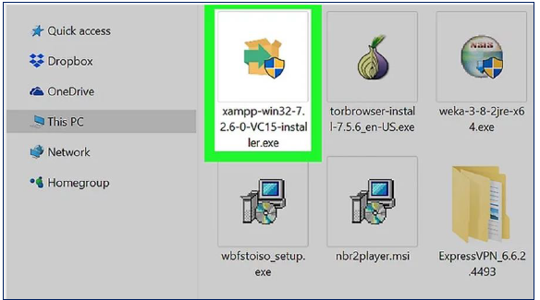Run the Xamp exe file on your computer
2. Select the components you want to install, in our case, we select all of them as precautionary measures.

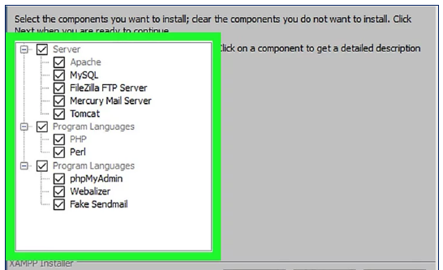

1. The next step is to click on the ‘Next’ button. A screen will appear asking which directory to install the program. By default, it is **‘C:\xampp’**, however this is can be modified to your desired directory.

After the ‘Next’ button, the following screen will appear:

It is advisable to uncheck it unless you want to learn in dept about XAMPP. This is optional.

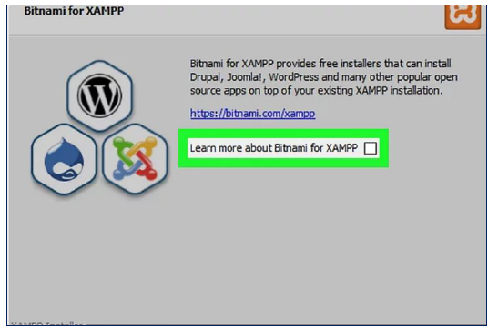

1. The program will now be installed and upon clicking on the ‘Finish’ button, a pop up will appear asking the language of the program in which to display.

Select your preferred language (most used: English) and click on ‘Ok’.

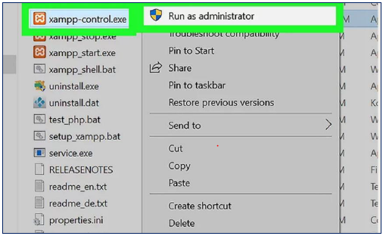As shown in the figure below, open the ‘xampp-control.exe’ with admin rights:

1. Once configured, the following control panel will appear, start Apache and MySQL only.

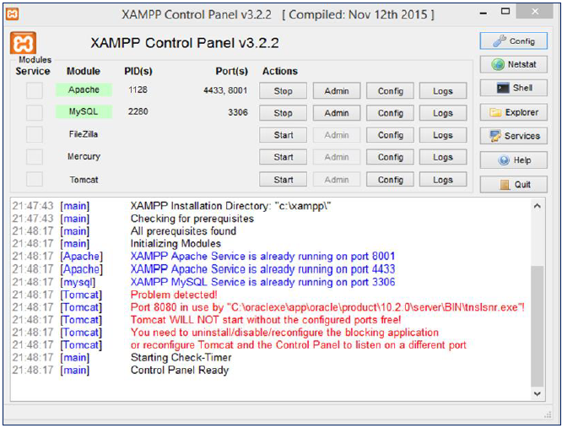

1. Phpmyadmin

Phpmyadmin is the repository where your database will be stored.

Steps to configure database:

1. Open your web browser and type in localhost followed by your port number for example, localhost:8000 or localhost:1234 or localhost:2646. If you are not sure about your port number, please see figure below to locate yours:



Once you entered <http://localhost:8001/> on your web browser, the following is displayed:

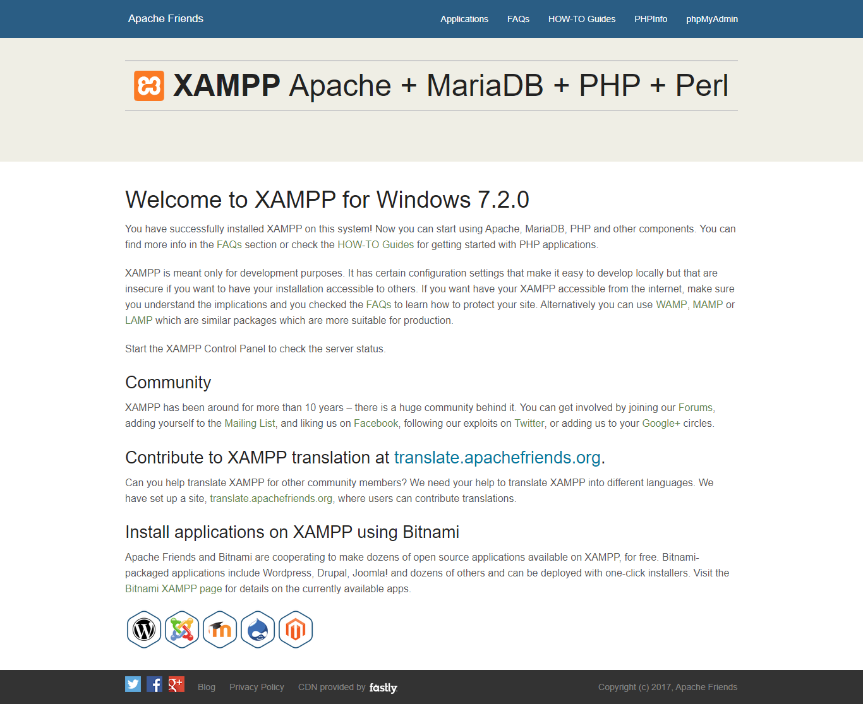

Select phpMyAdmin on the top right corner of the page and the following will be displayed:

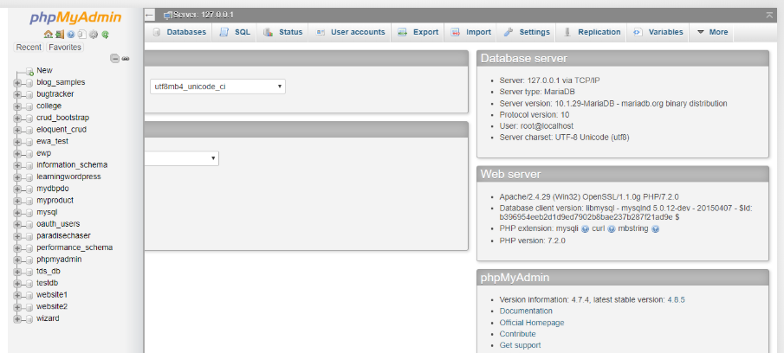

To create your database, click on **New** and type in “**paradisechaser**” as the database name, then go to **Import** and choose the file ***paradisechaser.sql***

After having successfully setup your database, go to **C:\xampp\htdocs** on your computer and copy the OnlineTravelTours folder there.

You have completed the configuration for your web application. It is now time to access the web application through any web browser.

To access paradisechaser, type in [http://localhost:**YOURPORTNUMBER**/OnlineTravelTours/](http://localhost:YOURPORTNUMBER/OnlineTravelTours/)

Paradise Chaser homepage will be displayed:

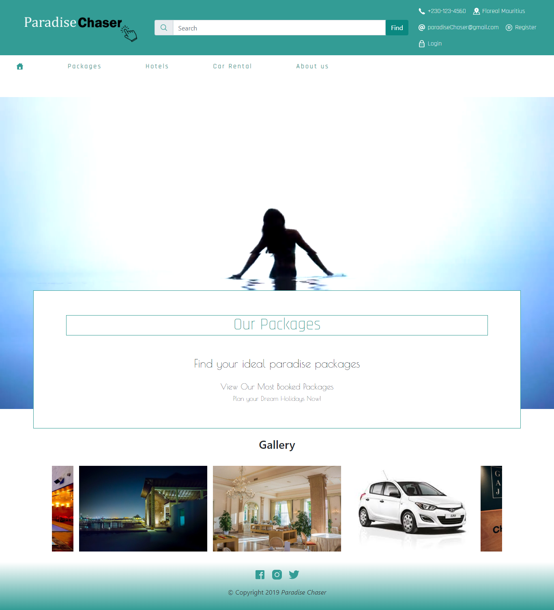

**Customer Section**

Steps: For new members

1. Register
   1. Click on the registration link found on the navigation menu and the following will appear:

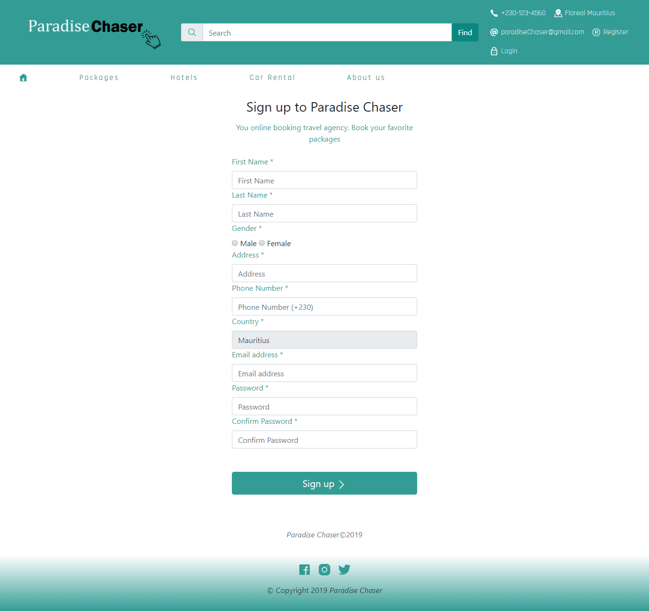

Kindly fill in the form with appropriate values.

After successful registration, the customer will be redirected to login page as shown below:

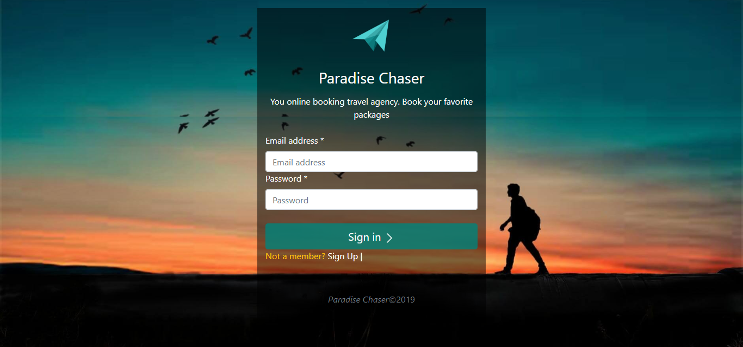

After login with valid credentials, the user will be redirected to homepage with his/her own account.

The header is changed to customer requirement including a shopping cart, a profile info and a logout button

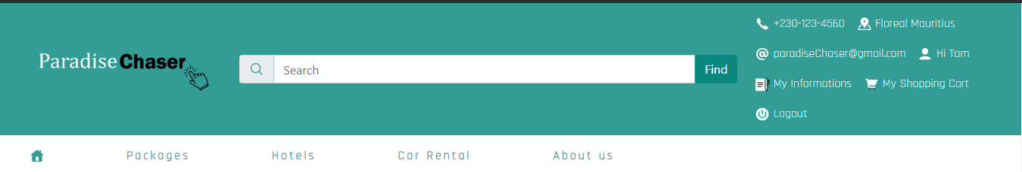

User can booked either a package typically divided in 3 parts that is a day package at a hotel, make car rental, or book a travel package to another country.

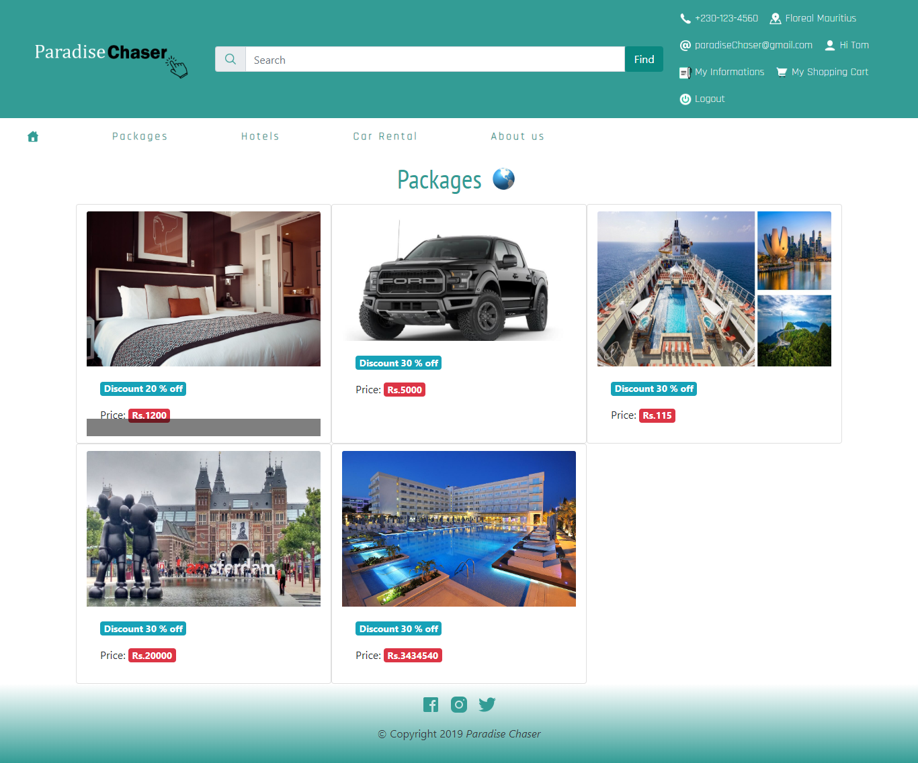

Booking example:

If a particular user wants to book a particular item from paradise chaser, the latter click on the item he/she want and the following appears depending on the package type:

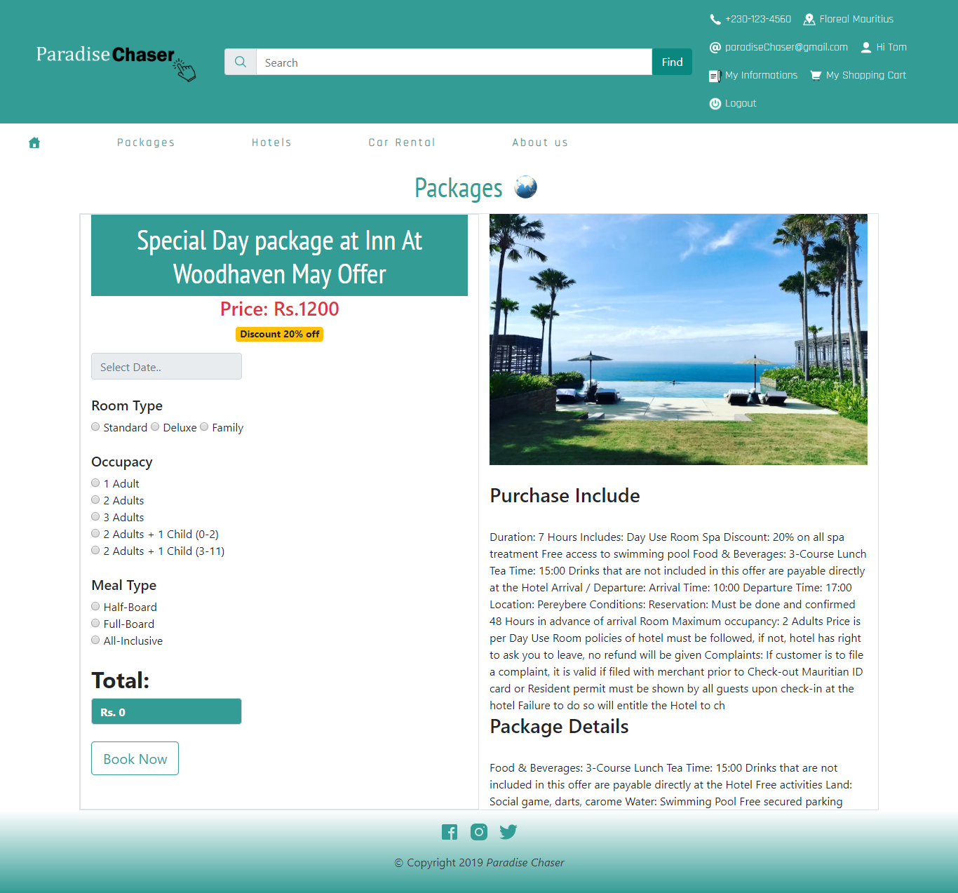

After successful booking, the item is added to the user shopping cart and upon checkout the customer is asked to select among 2 payment options as shown below:

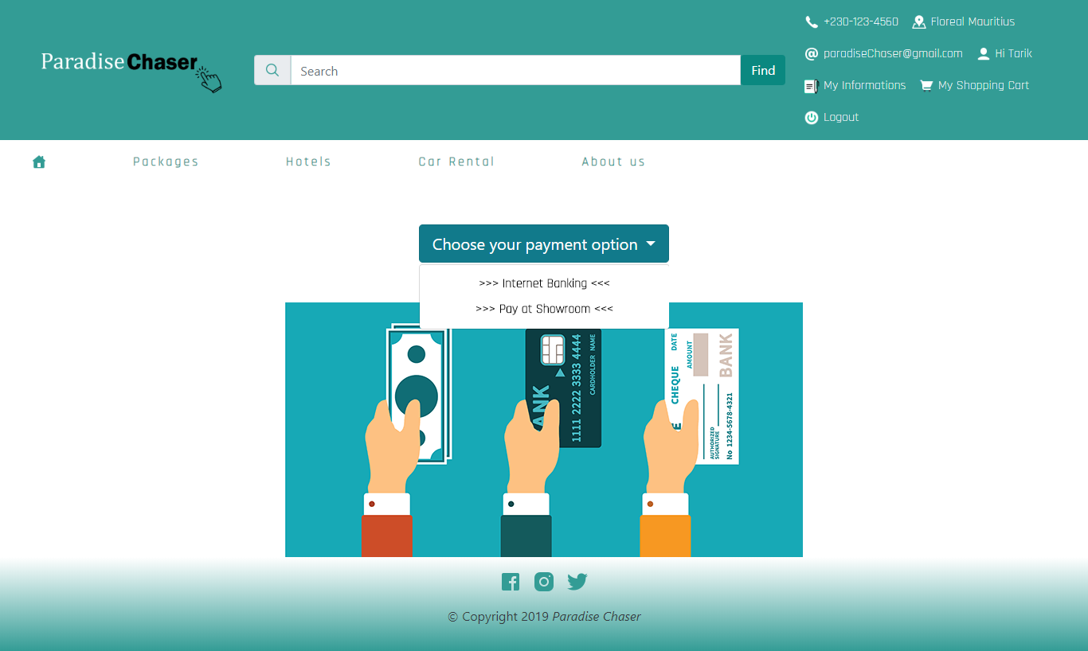

**Internet banking option**

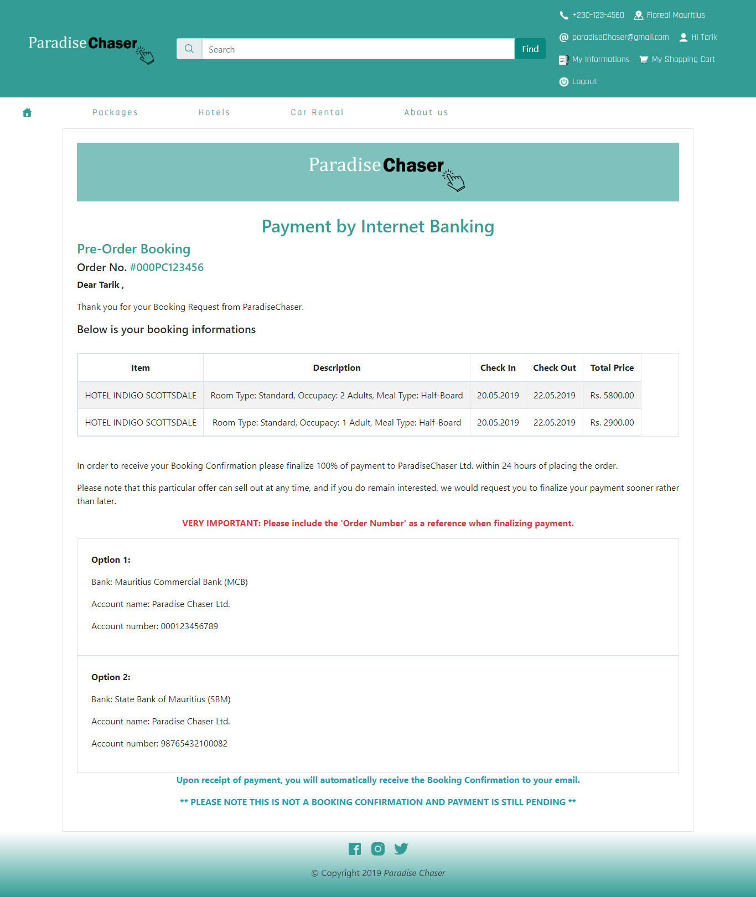

**Payment at showroom option**

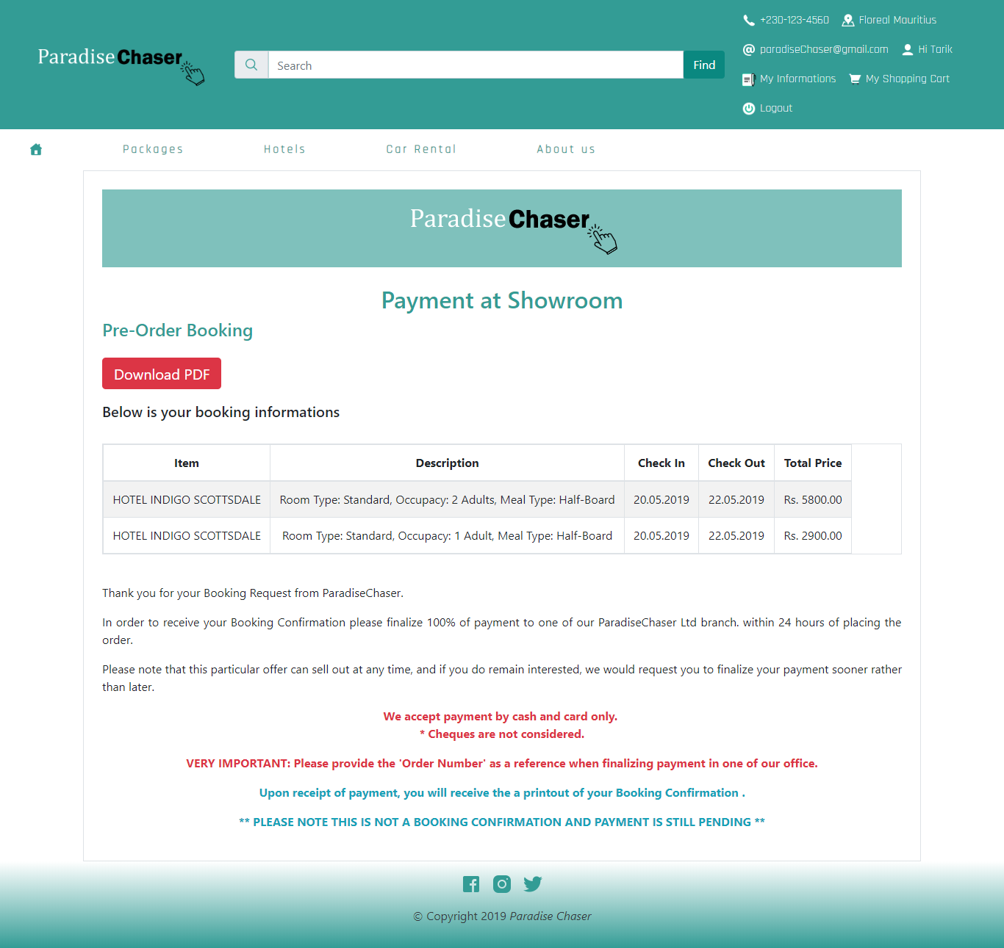

Download a PDF Version of page

After successful payment, the customer order is stored in his/her purchase history section.

**Admin Section**

Admin has the following credentials to login to the admin dashboard:

**Email: paradisechaser2019@gmail.com**

**Password: Pa$$w0rd!**

Below is a list of features that an admin can manage on the website:

1. **User**

Admin has the ability to block and unblock a customer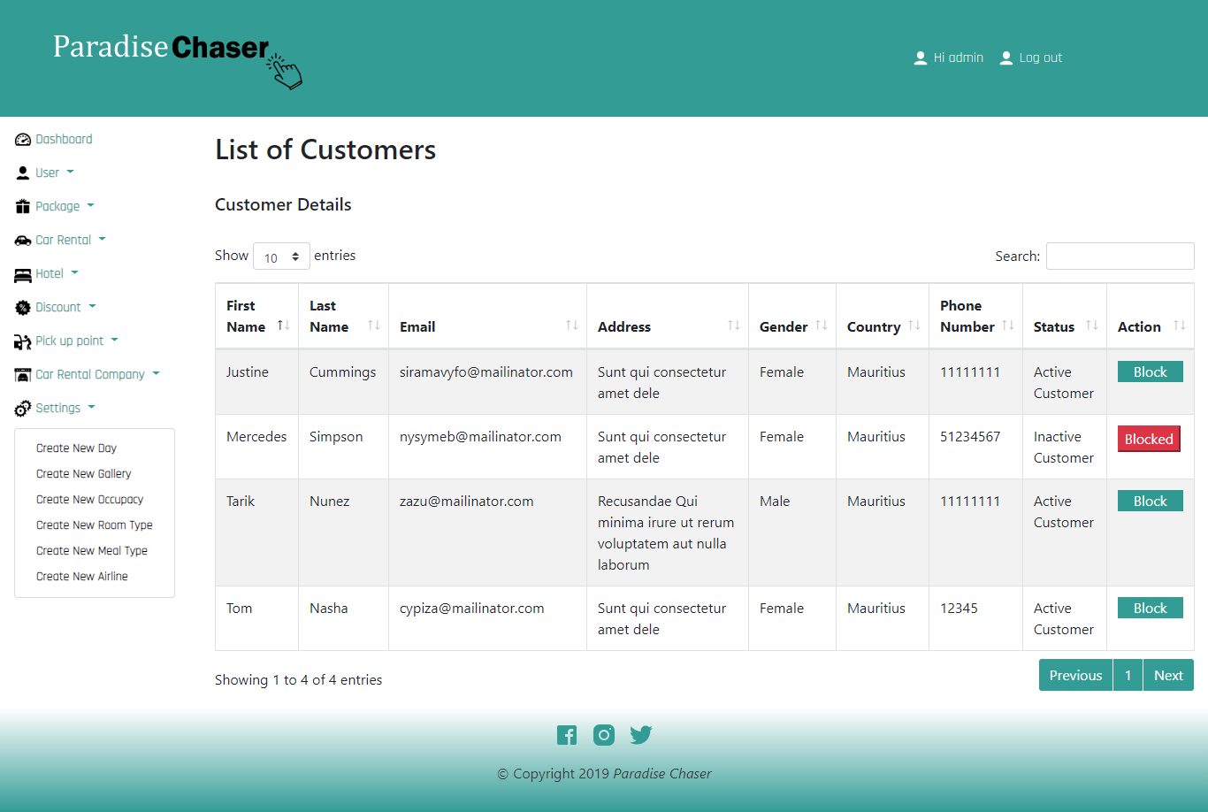.

1. Admin has the ability to add, update, remove a package, hotel or a car rental

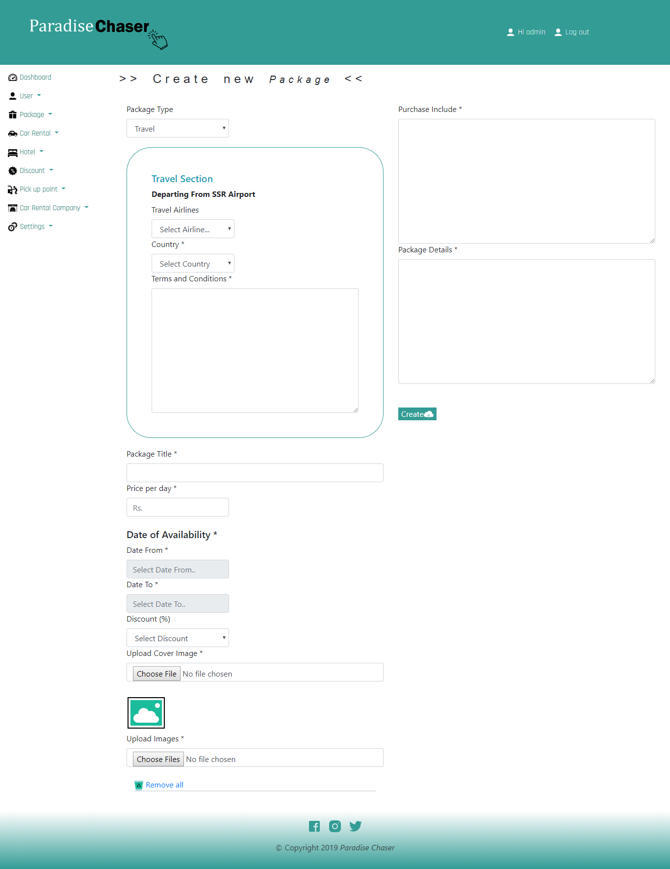

The following appear if admin selects travel

Available date for package.

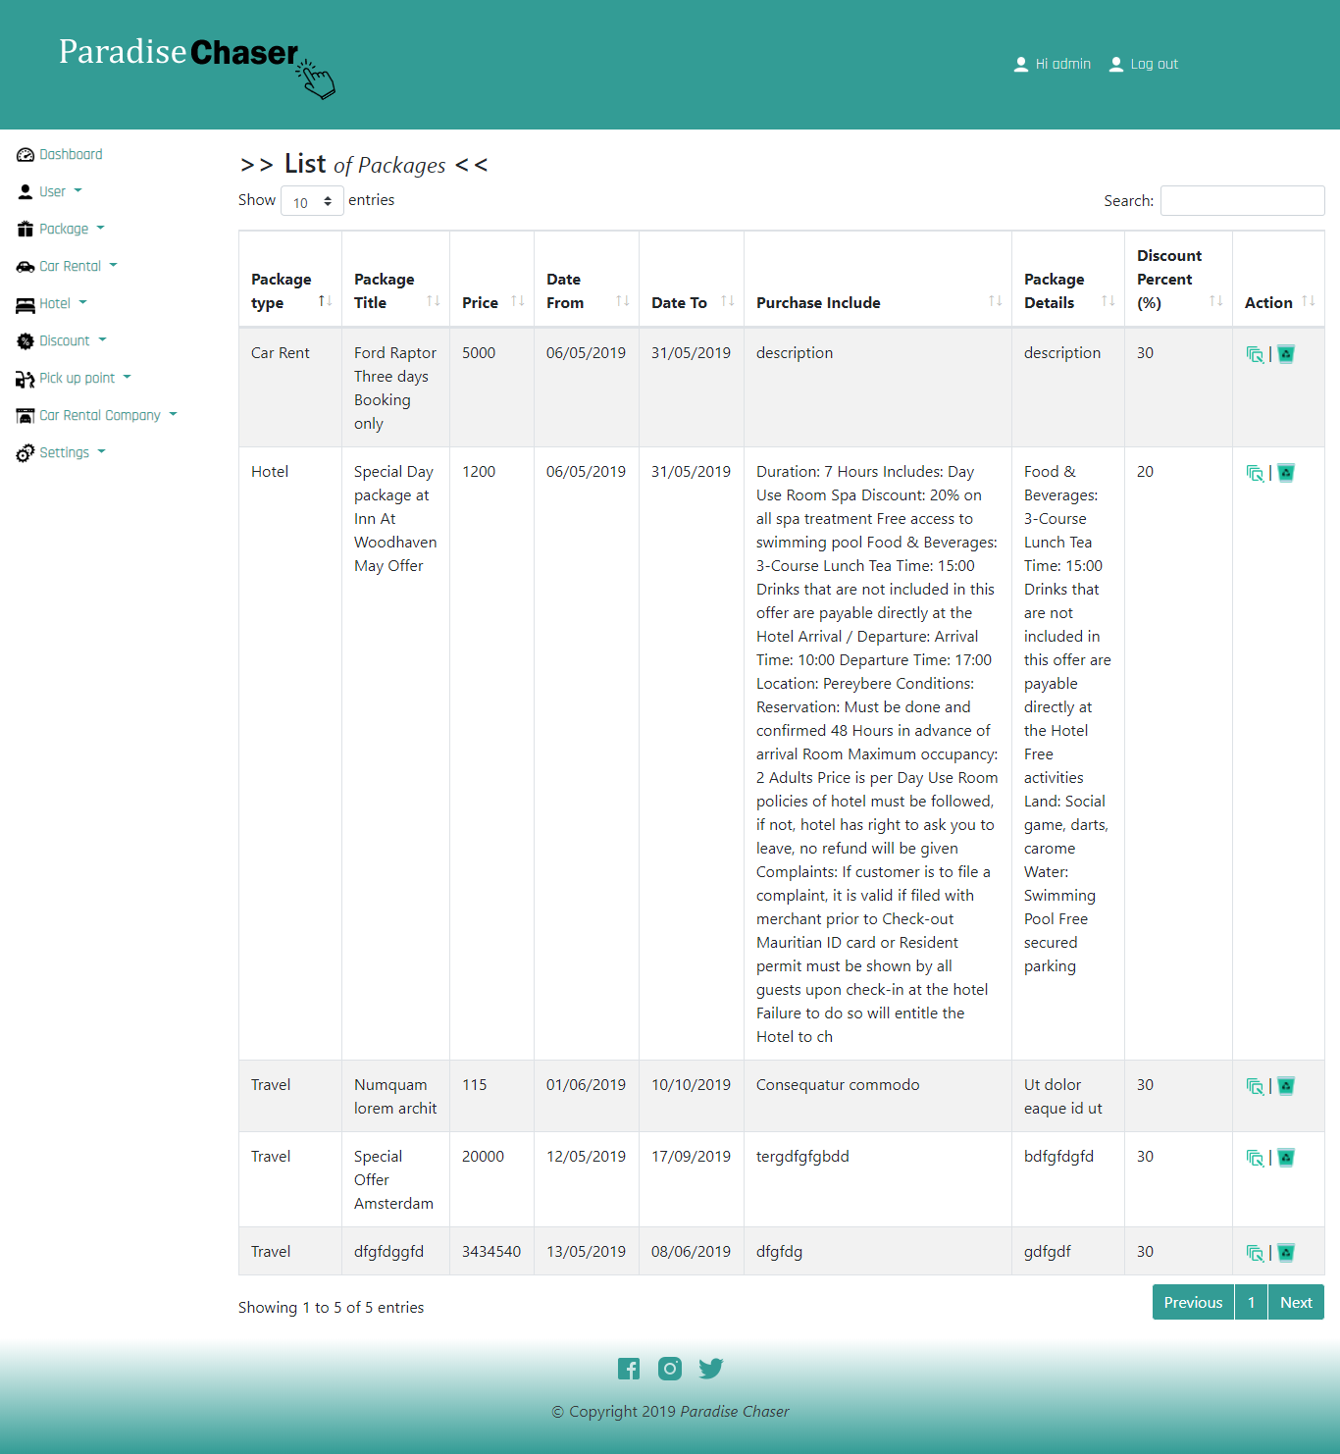

Admin also has the ability to change other settings for example pickup point

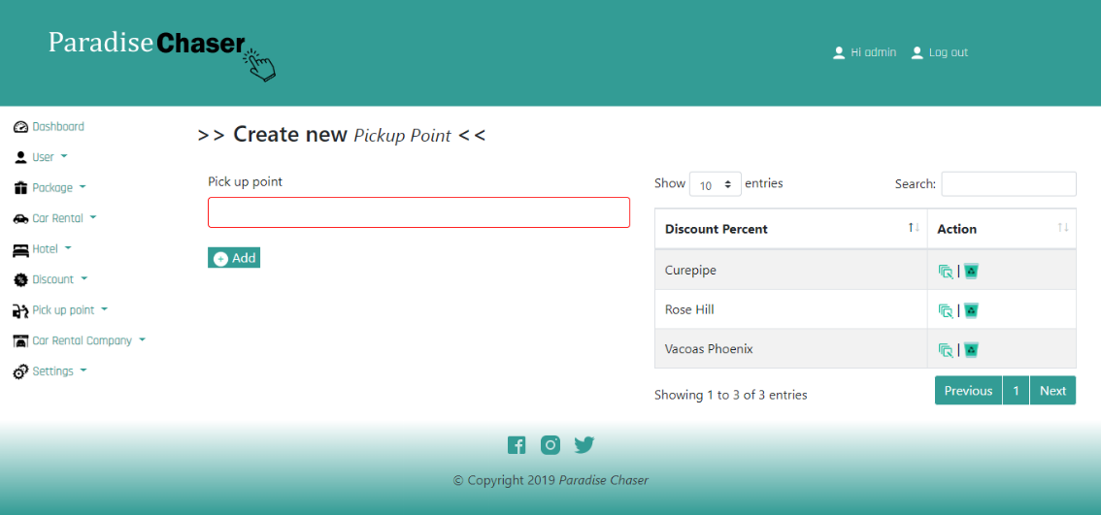

## 12.2 Annex

|  |  |
| --- | --- |
| Annex A | Student diary |
| Annex B | Student Diary Summary |
| Annex C | Project/ Dissertation Submission Form |
| Annex D | Certificate of Originality |